Concepts in Focus Get Exclusive Prime Deals
- Integrating APIs
  - Get Exclusive Prime Deals

- API Call Possible Views
  - Success View
  - Failure View
  - Loading View
- E-Commerce Application
- Best Practices
  - State Variable-isLoading
  - State Variable-apiStatus
  - Adding Initial State
Concepts in Focus
- setState() Callback Function
- React Icons
  - Installing React Icons
  - Searching React Icons
  - Importing React Icons
- Sorting Products
Concepts in Focus
- Reconciliation
  - Virtual DOM
- React Batch Updating
- setState() Syntax
  - Object Syntax
  - Callback Syntax
  - Object Syntax vs Callback Syntax
- Children Prop
  - Passing Text as Children
  - Accessing Children
- Controlled vs Uncontrolled Input
  - Controlled Input
  - Uncontrolled Input
- Props vs State
- State should be minimal
- Keys
  - Keys in Lists
Concepts in Focus
- Third-Party Packages
  - Advantages
  - Selecting a Third-Party Package
- Third-Party Package
react-player
  - React Player Props
- Reference
Concepts in Focus
- Third-Party Package
recharts
  - Advantages
- Bar Chart
- Components in Bar Chart
  - ResponsiveContainer
  - XAxis
  - YAxis
  - Legend
  - Bar
- Pie Chart
- Components in Pie Chart
  - Pie
  - Cell
- Reference
Concepts in Focus
- Third-Party Package
react-chrono
  - Advantages
- Chrono Props
  - mode
  - items
  - theme
- Rendering Custom Content
- Reference
Concepts in Focus
- Third-Party Package
react-slick
  - Advantages
- Slider Props
- Reference
Concepts in Focus
- Third-Party Package
reactjs-popup
  - Advantages
- ReactJS Popup Props
- Reference
Concepts in Focus
- Prop Drilling
- React Context
  - Creating Context
  - Context Properties
  - How to Access the Value?
- Consumer Component
  - Understanding Syntax
- Windows App Example
  - Initial Code
  - Final Code
- Google Translator
Concepts in Focus
- Provider
  - Syntax
- Context Flow For Windows App
- Best Practice
- Final Code
Concepts in Focus
- Context
- Using Context in methods
- Final Code
Concepts in Focus
- Deploying the Ecommerce Application Code
- Ecommerce Application-Final Code
Concepts in Focus
- Styling React Components
  - Using CSS
  - CSS-in-JS
- Styled Components
  - Installation
  - Syntax
  - Importing styled
  - Creating and Exporting Styled Component
  - Importing and Rendering Styled Component
  - Adapting based on props
  - Modularity of Code
  - Conditional Styling using Props
- Advantages of Styled Components
  - Unique Class Names
  - Elimination of dead styles
  - Dynamic Styling
  - Can differentiate between the types of props they receive
  - Easier Debugging
  - Global Styling
- Extending Styles
- The "as" prop
- Boolean Attribute

1. Integrating APIs
1.1 Get Exclusive Prime Deals
- Exclusive Prime deals are for Prime Users.
- All Products are for both Prime and Non-Prime users.
2. API Call Possible Views
2.1 Success View
When the Prime User is logged in and accessed Prime Deals Section then we should show the
Exclusive Prime Deals section.
2.2 Failure View
When the Non-prime User is logged in and accessed Prime Deals Section then we should show the Get Exclusive Deals
section.
Reasons for API Call Failure :
- Sending UnAuthorized User credentials
- Not specifying Authorization header
- Using the wrong HTTP method
2.3 Loading View
When the Prime or Non-prime User is logged in and accessed Prime Deals Section, we should show the Loading view
until data is in progress.

3. E-Commerce Application
File: src/App.js
JSX
import {BrowserRouter, Route, Switch, Redirect} from 'react-router-dom'

import LoginForm from './components/LoginForm'
import Home from './components/Home'
import Products from './components/Products'
import Cart from './components/Cart'
import NotFound from './components/NotFound'
import ProtectedRoute from './components/ProtectedRoute'

import './App.css'

const App = () => (
<BrowserRouter>
<Switch>
<Route exact path="/login" component={LoginForm} />
<ProtectedRoute exact path="/" component={Home} />
<ProtectedRoute exact path="/products" component={Products} />
<ProtectedRoute exact path="/cart" component={Cart} />
<Route path="/not-found" component={NotFound} />
<Redirect to="not-found" />
</Switch>
</BrowserRouter>
)

export default App

File: src/components/AllProductsSection/index.js
JSX
import {Component} from 'react'
import Loader from 'react-loader-spinner'
import Cookies from 'js-cookie'

import ProductCard from '../ProductCard'
import './index.css'

class AllProductsSection extends Component {
state = {
productsList: [],
isLoading: false,
}

componentDidMount() {
this.getProducts()
}

getProducts = async () => {
this.setState({
isLoading: true,
})
const jwtToken = Cookies.get('jwt_token')
const apiUrl = 'https://apis.ccbp.in/products'
const options = {
headers: {
Authorization: `Bearer ${jwtToken}`,
},
method: 'GET',
}
const response = await fetch(apiUrl, options)
if (response.ok) {
const fetchedData = await response.json()
const updatedData = fetchedData.products.map(product => ({
title: product.title,
brand: product.brand,
price: product.price,
id: product.id,
imageUrl: product.image_url,
rating: product.rating,
}))
this.setState({
productsList: updatedData,
isLoading: false,
})
}
}

renderProductsList = () => {
const {productsList} = this.state
return (
<>
<h1 className="products-list-heading">All Products</h1>
<ul className="products-list">
{productsList.map(product => (
<ProductCard productData={product} key={product.id} />
))}
</ul>
</>
)
}
renderLoader = () => (
<div className="products-loader-container">
<Loader type="ThreeDots" color="#0b69ff" height="50" width="50" />
</div>
)

render() {
const {isLoading} = this.state
return isLoading ? this.renderLoader() : this.renderProductsList()
}
}

export default AllProductsSection

File: src/components/Cart/index.js
JSX
import Header from '../Header'
import './index.css'

const Cart = () => (
<>
<Header />
<div className="cart-container">
<img
src="https://assets.ccbp.in/frontend/react-js/nxt-trendz-cart-img.png"
alt="cart"
className="cart-img"
/>
</div>
</>
)

export default Cart

File: src/components/Header/index.js
JSX
import {Link, withRouter} from 'react-router-dom'

import Cookies from 'js-cookie'

import './index.css'

const Header = props => {
const onClickLogout = () => {
Cookies.remove('jwt_token')
const {history} = props
history.replace('/login')
}
return (
<nav className="nav-header">
<div className="nav-content">
<Link to="/">
<img
className="website-logo"
src="https://assets.ccbp.in/frontend/react-js/nxt-trendz-logo-img.png"
alt="website logo"
/>
</Link>
<ul className="nav-menu">
<Link to="/" className="nav-link">
<li>Home</li>
</Link>
<Link to="/products" className="nav-link">
<li>Products</li>
</Link>
<Link to="/cart" className="nav-link">
<li>Cart</li>
</Link>
</ul>
<button
type="button"
className="logout-desktop-btn"
onClick={onClickLogout}
>
Logout
</button>
<button
type="button"
className="logout-mobile-btn"
onClick={onClickLogout}
>
<img
src="https://assets.ccbp.in/frontend/react-js/nxt-trendz-log-out-img.png"
alt="logout icon"
className="logout-icon"
/>
</button>
</div>
<div className="nav-menu-mobile">
<ul className="nav-menu-list-mobile">
<Link to="/">
<li className="nav-menu-item-mobile">
<img
src="https://assets.ccbp.in/frontend/react-js/nxt-trendz-home-icon.png"
alt="nav home"
className="nav-bar-image"
/>
</li>
</Link>
<Link to="/products">
<li className="nav-menu-item-mobile">
<img
src="https://assets.ccbp.in/frontend/react-js/nxt-trendz-products-icon.png"
alt="nav products"
className="nav-bar-image"
/>
</li>
</Link>
<Link to="/cart">
<li className="nav-menu-item-mobile">
<img
src="https://assets.ccbp.in/frontend/react-js/nxt-trendz-cart-icon.png"
alt="nav cart"
className="nav-bar-image"
/>
</li>
</Link>
</ul>
</div>
</nav>
)
}
export default withRouter(Header)

File: src/components/Home/index.js
JSX
import Cookies from 'js-cookie'
import {Redirect, Link} from 'react-router-dom'

import Header from '../Header'
import './index.css'

const Home = () => {
const jwtToken = Cookies.get('jwt_token')
if (jwtToken === undefined) {
return <Redirect to="/login" />
}

return (
<>
<Header />
<div className="home-container">
<div className="home-content">
<h1 className="home-heading">Clothes That Get YOU Noticed</h1>
<img
src="https://assets.ccbp.in/frontend/react-js/nxt-trendz-home-img.png"
alt="clothes to be noticed"
className="home-mobile-img"
/>
<p className="home-description">
Fashion is part of the daily air and it does not quite help that it
changes all the time. Clothes have always been a marker of the era
and we are in a revolution. Your fashion makes you been seen and
heard that way you are. So, celebrate the seasons new and exciting
fashion in your own way.
</p>
<Link to="/products">
<button type="button" className="shop-now-button">
Shop Now
</button>
</Link>
</div>
<img
src="https://assets.ccbp.in/frontend/react-js/nxt-trendz-home-img.png"
alt="dresses to be noticed"
className="home-desktop-img"
/>
</div>
</>
)
}

export default Home

File: src/components/LoginForm/index.js
JSX
import {Component} from 'react'
import Cookies from 'js-cookie'
import {Redirect} from 'react-router-dom'

import './index.css'

class LoginForm extends Component {
state = {
username: '',
password: '',
showSubmitError: false,
errorMsg: '',
}

onChangeUsername = event => {
this.setState({username: event.target.value})
}

onChangePassword = event => {
this.setState({password: event.target.value})
}

onSubmitSuccess = jwtToken => {
const {history} = this.props

Cookies.set('jwt_token', jwtToken, {
expires: 30,
path: '/',
})
history.replace('/')
}

onSubmitFailure = errorMsg => {
console.log(errorMsg)
this.setState({showSubmitError: true, errorMsg})
}

submitForm = async event => {
event.preventDefault()
const {username, password} = this.state
const userDetails = {username, password}
const url = 'https://apis.ccbp.in/login'
const options = {
method: 'POST',
body: JSON.stringify(userDetails),
}
const response = await fetch(url, options)
const data = await response.json()
if (response.ok === true) {
this.onSubmitSuccess(data.jwt_token)
} else {
this.onSubmitFailure(data.error_msg)
}
}

renderPasswordField = () => {
const {password} = this.state
return (
<>
<label className="input-label" htmlFor="password">
PASSWORD
</label>
<input
type="password"
id="password"
className="password-input-field"
value={password}
onChange={this.onChangePassword}
/>
</>
)
}
renderUsernameField = () => {
const {username} = this.state
return (
<>
<label className="input-label" htmlFor="username">
USERNAME
</label>
<input
type="text"
id="username"
className="username-input-field"
value={username}
onChange={this.onChangeUsername}
/>
</>
)
}
render() {
const {showSubmitError, errorMsg} = this.state
const jwtToken = Cookies.get('jwt_token')
if (jwtToken !== undefined) {
return <Redirect to="/" />
}
return (
<div className="login-form-container">
<img
src="https://assets.ccbp.in/frontend/react-js/nxt-trendz-logo-img.png"
className="login-website-logo-mobile-image"
alt="website logo"
/>
<img
src="https://assets.ccbp.in/frontend/react-js/nxt-trendz-login-img.png"
className="login-image"
alt="website login"
/>
<form className="form-container" onSubmit={this.submitForm}>
<img
src="https://assets.ccbp.in/frontend/react-js/nxt-trendz-logo-img.png"
className="login-website-logo-desktop-image"
alt="website logo"
/>
<div className="input-container">{this.renderUsernameField()}</div>
<div className="input-container">{this.renderPasswordField()}</div>
<button type="submit" className="login-button">
Login
</button>
{showSubmitError && <p className="error-message">*{errorMsg}</p>}
</form>
</div>
)
}
}

export default LoginForm

File: src/components/NotFound/index.js
JSX
import './index.css'

const NotFound = () => (
<div className="not-found-container">
<img
src="https://assets.ccbp.in/frontend/react-js/not-found-blog-img.png"
alt="not-found"
className="not-found-img"
/>
</div>
)

export default NotFound

File: src/components/PrimeDealsSection/index.js
JSX
import {Component} from 'react'
import Cookies from 'js-cookie'
import Loader from 'react-loader-spinner'

import ProductCard from '../ProductCard'
import './index.css'

const apiStatusConstants = {
initial: 'INITIAL',
success: 'SUCCESS',
failure: 'FAILURE',
inProgress: 'IN_PROGRESS',
}

class PrimeDealsSection extends Component {
state = {
primeDeals: [],
apiStatus: apiStatusConstants.initial,
}

componentDidMount() {
this.getPrimeDeals()
}

getPrimeDeals = async () => {
this.setState({
apiStatus: apiStatusConstants.inProgress,
})
const jwtToken = Cookies.get('jwt_token')

const apiUrl = 'https://apis.ccbp.in/prime-deals'
const options = {
headers: {
Authorization: `Bearer ${jwtToken}`,
},
method: 'GET',
}
const response = await fetch(apiUrl, options)
if (response.ok === true) {
const fetchedData = await response.json()
const updatedData = fetchedData.prime_deals.map(product => ({
title: product.title,
brand: product.brand,
price: product.price,
id: product.id,
imageUrl: product.image_url,
rating: product.rating,
}))
this.setState({
primeDeals: updatedData,
apiStatus: apiStatusConstants.success,
})
}
if (response.status === 401) {
this.setState({
apiStatus: apiStatusConstants.failure,
})
}
}
renderPrimeDealsList = () => {
const {primeDeals} = this.state
return (
<div>
<h1 className="primedeals-list-heading">Exclusive Prime Deals</h1>
<ul className="products-list">
{primeDeals.map(product => (
<ProductCard productData={product} key={product.id} />
))}
</ul>
</div>
)
}

renderPrimeDealsFailureView = () => (
<img
src="https://assets.ccbp.in/frontend/react-js/exclusive-deals-banner-img.png"
alt="Register Prime"
className="register-prime-image"
/>
)

renderLoadingView = () => (
<div className="products-loader-container">
<Loader type="ThreeDots" color="#0b69ff" height="50" width="50" />
</div>
)
render() {
const {apiStatus} = this.state
switch (apiStatus) {
case apiStatusConstants.success:
return this.renderPrimeDealsList()
case apiStatusConstants.failure:
return this.renderPrimeDealsFailureView()
case apiStatusConstants.inProgress:
return this.renderLoadingView()
default:
return null
}
}
}

export default PrimeDealsSection

File: src/components/ProductCard/index.js
JSX
import './index.css'

const ProductCard = props => {
const {productData} = props
const {title, brand, imageUrl, rating, price} = productData

return (
<li className="product-item">
<img src={imageUrl} alt="product" className="thumbnail" />
<h1 className="title">{title}</h1>
<p className="brand">by {brand}</p>
<div className="product-details">
<p className="price">Rs {price}/-</p>
<div className="rating-container">
<p className="rating">{rating}</p>
<img
src="https://assets.ccbp.in/frontend/react-js/star-img.png"
alt="star"
className="star"
/>
</div>
</div>
</li>
)
}
export default ProductCard

File: src/components/Products/index.js
JSX
import AllProductsSection from '../AllProductsSection'
import PrimeDealsSection from '../PrimeDealsSection'

import Header from '../Header'

import './index.css'

const Products = () => (
<>
<Header />
<div className="product-sections">
<PrimeDealsSection />
<AllProductsSection />
</div>
</>
)

export default Products

File: src/components/ProtectedRoute/index.js
JSX
import {Redirect, Route} from 'react-router-dom'
import Cookie from 'js-cookie'

const ProtectedRoute = props => {
const token = Cookie.get('jwt_token')
if (token === undefined) {
return <Redirect to="/login" />
}
return <Route {...props} />
}

export default ProtectedRoute

4. Best Practices
4.1 State Variable-isLoading
isLoading is used to handle Success View, Loading View only.
JSX
render() {
const {isLoading} = this.state
return <>
{ isLoading ? this.renderLoader() : this.renderProductsList() }
</>
}
4.2 State Variable-apiStatus
apiStatus is used to handle Success, Failure and Loading Views.
JSX
switch (apiStatus) {
case apiStatusConstants.success:
return this.renderPrimeDealsList()
...
...
default:
return null
}

4.3 Adding Initial State
Instead of adding empty strings in initial state we can add initial in apiStatusConstants.
File: src/components/PrimeDealsSection/index.js
JSX
...
const apiStatusConstants = {
initial: "INITIAL",
inProgress: "IN_PROGRESS",
success: "SUCCESS",
failure: "FAILURE",
};
class PrimeDealsSection extends Component {
state = {
primeDeals: [],
apiStatus: apiStatusConstants.initial,
}

renderPrimeDeals = () => {
const { apiStatus } = this.state;
switch (apiStatus) {
case apiStatusConstants.success:
return this.renderPrimeDealsSuccessView();
case apiStatusConstants.failure:
return this.renderPrimeDealsFailureView();
case apiStatusConstants.inProgress:
return this.renderLoader();
default:
return null;
}
};

render() {
return <>{this.renderPrimeDeals()}</>
}
}

export default PrimeDealsSection

1. setState() - Callback Function
- The setState()
is asynchronous, it takes an optional callback parameter that can be used to make updates after the state is changed.
Syntax
JSX
this.setState({property1: value1,...}, callbackFunction)
2. React Icons
- react-icons
is a third-party package contains bundle of icons like bootstrap, font awesome, material icons etc..,
- Check react-icons website here .
2.1 Installing React Icons
- This below command installs all the react-icons library in your React project.
npm install react-icons
2.2 Searching React Icons
- Click on the Icon to copy the Icon Name.
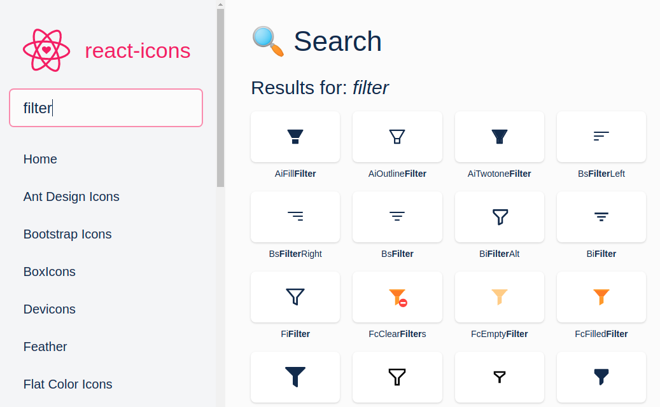

2.3 Importing React Icons
- The First letters of the icon indicates the category of the Icon.
- Each category of Icons have import statements separately, go to the category and copy the import statement.
Example:
JSX
import { BsFilterRight } from "react-icons/bs";
import { FaFacebookF } from "react-icons/fa";
import { MdDelete } from "react-icons/md";

const ReactIcon = (props) => {
return (
<div>
<BsFilterRight />
<FaFacebookF />
<MdDelete />
</div>
);
};

export default ReactIcon;

3. Sorting Products
File: src/components/AllProductsSection
JSX
import {Component} from 'react'
import Loader from 'react-loader-spinner'
import Cookies from 'js-cookie'

import ProductCard from '../ProductCard'
import ProductsHeader from '../ProductsHeader'
import './index.css'

const sortbyOptions = [
{
optionId: 'PRICE_HIGH',
displayText: 'Price (High-Low)',
},
{
optionId: 'PRICE_LOW',
displayText: 'Price (Low-High)',
},
]

class AllProductsSection extends Component {
state = {
productsList: [],
isLoading: false,
activeOptionId: sortbyOptions[0].optionId,
}

componentDidMount() {
this.getProducts()
}
getProducts = async () => {
this.setState({
isLoading: true,
})
const jwtToken = Cookies.get('jwt_token')
const {activeOptionId} = this.state
const apiUrl = `https://apis.ccbp.in/products?sort_by=${activeOptionId}`
const options = {
headers: {
Authorization: `Bearer ${jwtToken}`,
},
method: 'GET',
}
const response = await fetch(apiUrl, options)
if (response.ok) {
const fetchedData = await response.json()
const updatedData = fetchedData.products.map(product => ({
title: product.title,
brand: product.brand,
price: product.price,
id: product.id,
imageUrl: product.image_url,
rating: product.rating,
}))
this.setState({
productsList: updatedData,
isLoading: false,
})
}
}
updateActiveOptionId = activeOptionId => {
this.setState({activeOptionId}, this.getProducts)
}

renderProductsList = () => {
const {productsList, activeOptionId} = this.state
return (
<>
<ProductsHeader
activeOptionId={activeOptionId}
sortbyOptions={sortbyOptions}
updateActiveOptionId={this.updateActiveOptionId}
/>
<ul className="products-list">
{productsList.map(product => (
<ProductCard productData={product} key={product.id} />
))}
</ul>
</>
)
}

renderLoader = () => (
<div className="products-loader-container">
<Loader type="ThreeDots" color="#0b69ff" height="50" width="50" />
</div>
)

render() {
const {isLoading} = this.state
return isLoading ? this.renderLoader() : this.renderProductsList()
}
}

export default AllProductsSection

File: src/components/Cart
JSX
import Header from '../Header'
import './index.css'

const Cart = () => (
<>
<Header />
<div className="cart-container">
<img
src="https://assets.ccbp.in/frontend/react-js/nxt-trendz-cart-img.png"
alt="cart"
className="cart-img"
/>
</div>
</>
)

export default Cart

File: src/components/Header
JSX
import {Link, withRouter} from 'react-router-dom'

import Cookies from 'js-cookie'

import './index.css'

const Header = props => {
const onClickLogout = () => {
Cookies.remove('jwt_token')
const {history} = props
history.replace('/login')
}
return (
<nav className="nav-header">
<div className="nav-content">
<Link to="/">
<img
className="website-logo"
src="https://assets.ccbp.in/frontend/react-js/nxt-trendz-logo-img.png"
alt="website logo"
/>
</Link>
<ul className="nav-menu">
<Link to="/" className="nav-link">
<li>Home</li>
</Link>
<Link to="/products" className="nav-link">
<li>Products</li>
</Link>
<Link to="/cart" className="nav-link">
<li>Cart</li>
</Link>
</ul>
<button
type="button"
className="logout-desktop-btn"
onClick={onClickLogout}
>
Logout
</button>
<button
type="button"
className="logout-mobile-btn"
onClick={onClickLogout}
>
<img
src="https://assets.ccbp.in/frontend/react-js/nxt-trendz-log-out-img.png"
alt="logout icon"
className="logout-icon"
/>
</button>
</div>
<div className="nav-menu-mobile">
<ul className="nav-menu-list-mobile">
<Link to="/">
<li className="nav-menu-item-mobile">
<img
src="https://assets.ccbp.in/frontend/react-js/nxt-trendz-home-icon.png"
alt="nav home"
className="nav-bar-image"
/>
</li>
</Link>
<Link to="/products">
<li className="nav-menu-item-mobile">
<img
src="https://assets.ccbp.in/frontend/react-js/nxt-trendz-products-icon.png"
alt="nav products"
className="nav-bar-image"
/>
</li>
</Link>
<Link to="/cart">
<li className="nav-menu-item-mobile">
<img
src="https://assets.ccbp.in/frontend/react-js/nxt-trendz-cart-icon.png"
alt="nav cart"
className="nav-bar-image"
/>
</li>
</Link>
</ul>
</div>
</nav>
)
}
export default withRouter(Header)

File: src/components/Home
JSX
import Cookies from 'js-cookie'
import {Redirect, Link} from 'react-router-dom'

import Header from '../Header'
import './index.css'

const Home = () => {
const jwtToken = Cookies.get('jwt_token')
if (jwtToken === undefined) {
return <Redirect to="/login" />
}

return (
<>
<Header />
<div className="home-container">
<div className="home-content">
<h1 className="home-heading">Clothes That Get YOU Noticed</h1>
<img
src="https://assets.ccbp.in/frontend/react-js/nxt-trendz-home-img.png"
alt="dresses to be noticed"
className="home-mobile-img"
/>
<p className="home-description">
Fashion is part of the daily air and it does not quite help that it
changes all the time. Clothes have always been a marker of the era
and we are in a revolution. Your fashion makes you been seen and
heard that way you are. So, celebrate the seasons new and exciting
fashion in your own way.
</p>

<Link to="/products">
<button type="button" className="shop-now-button">
Shop Now
</button>
</Link>
</div>
<img
src="https://assets.ccbp.in/frontend/react-js/nxt-trendz-home-img.png"
alt="dresses to be noticed"
className="home-desktop-img"
/>
</div>
</>
)
}

export default Home

File: src/components/LoginForm
JSX
import {Component} from 'react'
import Cookies from 'js-cookie'
import {Redirect} from 'react-router-dom'

import './index.css'

class LoginForm extends Component {
state = {
username: '',
password: '',
showSubmitError: false,
errorMsg: '',
}

onChangeUsername = event => {
this.setState({username: event.target.value})
}

onChangePassword = event => {
this.setState({password: event.target.value})
}

onSubmitSuccess = jwtToken => {
const {history} = this.props

Cookies.set('jwt_token', jwtToken, {
expires: 30,
path: '/',
})
history.replace('/')
}

onSubmitFailure = errorMsg => {
console.log(errorMsg)
this.setState({showSubmitError: true, errorMsg})
}
submitForm = async event => {
event.preventDefault()
const {username, password} = this.state
const userDetails = {username, password}
const url = 'https://apis.ccbp.in/login'
const options = {
method: 'POST',
body: JSON.stringify(userDetails),
}
const response = await fetch(url, options)
const data = await response.json()
if (response.ok === true) {
this.onSubmitSuccess(data.jwt_token)
} else {
this.onSubmitFailure(data.error_msg)
}
}

renderPasswordField = () => {
const {password} = this.state
return (
<>
<label className="input-label" htmlFor="password">
PASSWORD
</label>
<input
type="password"
id="password"
className="password-input-field"
value={password}
onChange={this.onChangePassword}
/>
</>
)
}
renderUsernameField = () => {
const {username} = this.state
return (
<>
<label className="input-label" htmlFor="username">
USERNAME
</label>
<input
type="text"
id="username"
className="username-input-field"
value={username}
onChange={this.onChangeUsername}
/>
</>
)
}
render() {
const {showSubmitError, errorMsg} = this.state
const jwtToken = Cookies.get('jwt_token')
if (jwtToken !== undefined) {
return <Redirect to="/" />
}
return (
<div className="login-form-container">
<img
src="https://assets.ccbp.in/frontend/react-js/nxt-trendz-logo-img.png"
className="login-website-logo-mobile-image"
alt="website logo"
/>
<img
src="https://assets.ccbp.in/frontend/react-js/nxt-trendz-login-img.png"
className="login-image"
alt="website login"
/>
<form className="form-container" onSubmit={this.submitForm}>
<img
src="https://assets.ccbp.in/frontend/react-js/nxt-trendz-logo-img.png"
className="login-website-logo-desktop-image"
alt="website logo"
/>
<div className="input-container">{this.renderUsernameField()}</div>
<div className="input-container">{this.renderPasswordField()}</div>
<button type="submit" className="login-button">
Login
</button>
{showSubmitError && <p className="error-message">*{errorMsg}</p>}
</form>
</div>
)
}
}

export default LoginForm

File: src/components/NotFound
JSX
import './index.css'

const NotFound = () => (
<div className="not-found-container">
<img
src="https://assets.ccbp.in/frontend/react-js/not-found-blog-img.png"
alt="not-found"
className="not-found-img"
/>
</div>
)

export default NotFound

File: src/components/PrimeDealsSection
JSX
import {Component} from 'react'
import Cookies from 'js-cookie'
import Loader from 'react-loader-spinner'

import ProductCard from '../ProductCard'
import './index.css'

const apiStatusConstants = {
initial: 'INITIAL',
success: 'SUCCESS',
failure: 'FAILURE',
inProgress: 'IN_PROGRESS',
}

class PrimeDealsSection extends Component {
state = {
primeDeals: [],
apiStatus: apiStatusConstants.initial,
}

componentDidMount() {
this.getPrimeDeals()
}

getPrimeDeals = async () => {
this.setState({
apiStatus: apiStatusConstants.inProgress,
})
const jwtToken = Cookies.get('jwt_token')

const apiUrl = 'https://apis.ccbp.in/prime-deals'
const options = {
headers: {
Authorization: `Bearer ${jwtToken}`,
},
method: 'GET',
}
const response = await fetch(apiUrl, options)
if (response.ok === true) {
const fetchedData = await response.json()
const updatedData = fetchedData.prime_deals.map(product => ({
title: product.title,
brand: product.brand,
price: product.price,
id: product.id,
imageUrl: product.image_url,
rating: product.rating,
}))
this.setState({
primeDeals: updatedData,
apiStatus: apiStatusConstants.success,
})
} else if (response.status === 401) {
this.setState({
apiStatus: apiStatusConstants.failure,
})
}
}
renderPrimeDealsList = () => {
const {primeDeals} = this.state
return (
<div>
<h1 className="primedeals-list-heading">Exclusive Prime Deals</h1>
<ul className="products-list">
{primeDeals.map(product => (
<ProductCard productData={product} key={product.id} />
))}
</ul>
</div>
)
}

renderPrimeDealsFailureView = () => (
<img
src="https://assets.ccbp.in/frontend/react-js/exclusive-deals-banner-img.png"
alt="Register Prime"
className="register-prime-image"
/>
)

renderLoadingView = () => (
<div className="products-loader-container">
<Loader type="ThreeDots" color="#0b69ff" height="50" width="50" />
</div>
)
render() {
const {apiStatus} = this.state
switch (apiStatus) {
case apiStatusConstants.success:
return this.renderPrimeDealsList()
case apiStatusConstants.failure:
return this.renderPrimeDealsFailureView()
case apiStatusConstants.inProgress:
return this.renderLoadingView()
default:
return null
}
}
}

export default PrimeDealsSection

File: src/components/ProductCard
JSX
import './index.css'

const ProductCard = props => {
const {productData} = props
const {title, brand, imageUrl, rating, price} = productData

return (
<li className="product-item">
<img src={imageUrl} alt="product" className="thumbnail" />
<h1 className="title">{title}</h1>
<p className="brand">by {brand}</p>
<div className="product-details">
<p className="price">Rs {price}/-</p>
<div className="rating-container">
<p className="rating">{rating}</p>
<img
src="https://assets.ccbp.in/frontend/react-js/star-img.png"
alt="star"
className="star"
/>
</div>
</div>
</li>
)
}
export default ProductCard

File: src/components/Products
JSX
import AllProductsSection from '../AllProductsSection'
import PrimeDealsSection from '../PrimeDealsSection'

import Header from '../Header'

import './index.css'

const Products = () => (
<>
<Header />
<div className="product-sections">
<PrimeDealsSection />
<AllProductsSection />
</div>
</>
)

export default Products

File: src/components/ProductsHeader
JSX
import {BsFilterRight} from 'react-icons/bs'

import './index.css'

const ProductsHeader = props => {
const {sortbyOptions, activeOptionId, updateActiveOptionId} = props
const onChangeSortby = event => {
updateActiveOptionId(event.target.value)
}

return (
<div className="products-header">
<h1 className="products-list-heading">All Products</h1>
<div className="sort-by-container">
<BsFilterRight className="sort-by-icon" />
<h1 className="sort-by">Sort by</h1>
<select
className="sort-by-select"
value={activeOptionId}
onChange={onChangeSortby}
>
{sortbyOptions.map(eachOption => (
<option
key={eachOption.optionId}
value={eachOption.optionId}
className="select-option"
>
{eachOption.displayText}
</option>
))}
</select>
</div>
</div>
)
}

export default ProductsHeader

File: src/components/ProtectedRoute
JSX
import {Redirect, Route} from 'react-router-dom'
import Cookie from 'js-cookie'

const ProtectedRoute = props => {
const token = Cookie.get('jwt_token')
if (token === undefined) {
return <Redirect to="/login" />
}
return <Route {...props} />
}

export default ProtectedRoute

File: src/App.js
JSX
import {BrowserRouter, Route, Switch, Redirect} from 'react-router-dom'

import LoginForm from './components/LoginForm'
import Home from './components/Home'
import Products from './components/Products'
import Cart from './components/Cart'
import NotFound from './components/NotFound'
import ProtectedRoute from './components/ProtectedRoute'

import './App.css'

const App = () => (
<BrowserRouter>
<Switch>
<Route exact path="/login" component={LoginForm} />
<ProtectedRoute exact path="/" component={Home} />
<ProtectedRoute exact path="/products" component={Products} />
<ProtectedRoute exact path="/cart" component={Cart} />
<Route path="/not-found" component={NotFound} />
<Redirect to="not-found" />
</Switch>
</BrowserRouter>
)

export default App

1. Reconciliation
1.1 Virtual DOM
A Virtual DOM is a JS object, which is the virtual representation of an HTML DOM.
Whenever new elements are added to the UI, a virtual DOM is created.
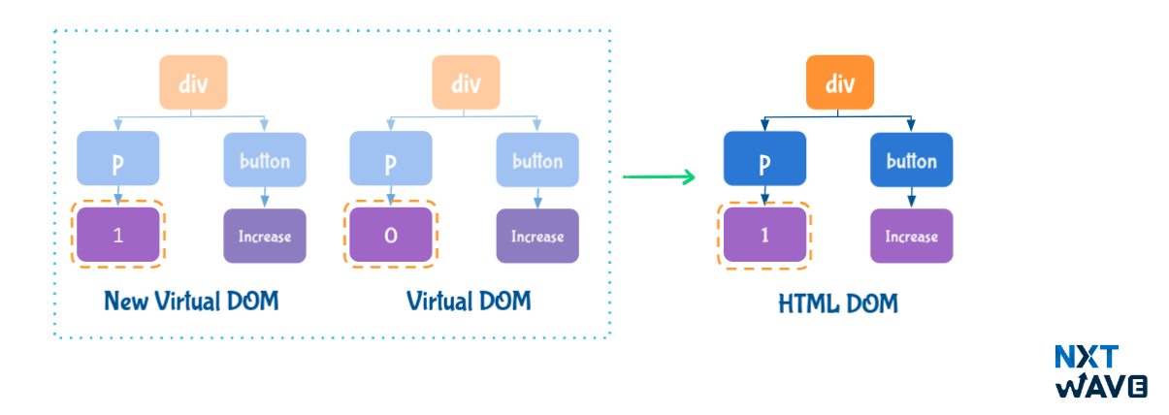
React compares new virtual DOM with current virtual DOM, and the difference will be efficiently updated to HTML DOM. So, the Virtual DOM helps to render the UI more performantly.
React only updates what's necessary. This process is known as Reconciliation.
2. React Batch Updating
React combines multiple
setState()
calls into single update.
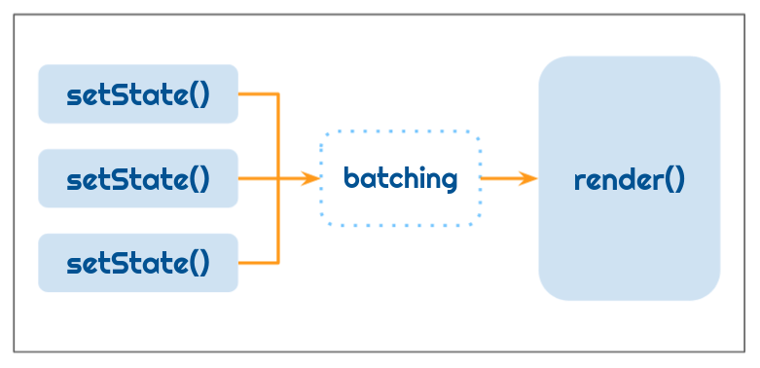
Example:
JSX
import { Component } from "react"

class Counter extends Component {
state = { count: 0 }

onIncrement = () => {
this.setState((prevState) => ({ count: prevState.count + 1 }))
this.setState((prevState) => ({ count: prevState.count + 1 }))
this.setState((prevState) => ({ count: prevState.count + 1 }))
}

render() {
const { count } = this.state
console.log("render() called")
return (
<>
<p className="count">Count {count}</p>
<button onClick={this.onIncrement}>Increase</button>
</>
)
}
}

export default Counter

In the above example, the render is called only once as React combines multiple setState()
calls into a single update.
3. setState() Syntax
3.1 Object Syntax
Object Syntax is used while updating the state to a value.
JSX
this.setState({
count: 5,
})

3.2 Callback Syntax
Callback Syntax is used while updating the state to a value that is computed based on the previous state.
JSX
this.setState((prevState) => ({ count: prevState.count + 1 }))

3.3 Object Syntax vs Callback Syntax
Object Syntax:
JSX
import { Component } from "react"

class Counter extends Component {
state = { count: 0 }

onIncrement = () => {
this.setState({ count: this.state.count + 1 })
this.setState({ count: this.state.count + 1 })
this.setState({ count: this.state.count + 1 })
}

render() {
const { count } = this.state
return (
<>
<p className="count">Count {count}</p>
<button onClick={this.onIncrement}>Increase</button>
</>
)
}
}

export default Counter

When the HTML button element is clicked, the value of the state variable count is 1.
When the Object Syntax is used, this.state.count is same for every setState statement as setState
is asynchronous.

Callback Syntax:
JSX
import { Component } from "react"

class Counter extends Component {
state = { count: 0 }

onIncrement = () => {
this.setState((prevState) => ({ count: prevState.count + 1 }))
this.setState((prevState) => ({ count: prevState.count + 1 }))
this.setState((prevState) => ({ count: prevState.count + 1 }))
}

render() {
const { count } = this.state
return (
<>
<p className="count">Count {count}</p>
<button onClick={this.onIncrement}>Increase</button>
</>
)
}
}

export default Counter

When the HTML button element is clicked, the value of the state variable count is 3.
The setState callback function receive prevState as an argument. So, it will receive an updated state value when it is executed.
4. Children Prop
The children is a special prop that is automatically passed to every React Component.
The JSX Element/Text included in between the opening and closing tags are considered children.
4.1 Passing Text as Children
File: src/components/Post/index.js

JSX
import "./index.css"
import SocialButton from "./SocialButton"

const Post = () => (
<div className="post-container">
<p className="paragraph">Hooks are a new addition</p>
<SocialButton>Like</SocialButton>
</div>
)

export default Post

4.2 Accessing Children
File: src/components/SocialButton/index.js
JSX
import "./index.css"

const SocialButton = (props) => (
<button className="social-button">{props.children}</button>
)

export default SocialButton

5. Controlled vs Uncontrolled Input
In React, the Input Element value can be handled in two ways:
- Controlled Input
- Uncontrolled Input
5.1 Controlled Input
If the Input Element value is handled by a React State, then it is called Controlled Input.
It is the React Suggested way to handle the Input Element value.
Example:
JSX
import { Component } from "react"

class App extends Component {
state = {
searchInput: "",
}

onChangeSearchInput = (event) => {
this.setState({
searchInput: event.target.value,
})
}

render() {
const { searchInput } = this.state
return (
<>
<input
type="text"
onChange={this.onChangeSearchInput}
value={searchInput}
/>
<p>{searchInput}</p>
</>
)
}
}

export default App

5.2 Uncontrolled Input
If the Input Element Value is handled by the browser itself, then it is called Uncontrolled Input.
Example:
JSX
import { Component } from "react"

class App extends Component {
state = {
searchInput: "",
}

onChangeSearchInput = (event) => {
this.setState({
searchInput: event.target.value,
})
}

render() {
const { searchInput } = this.state
return (
<>
<input type="text" onChange={this.onChangeSearchInput} />
<p>{searchInput}</p>
</>
)
}
}

export default App

6. Props vs State
- The props and state are plain JS objects.
- The props and state changes trigger the render method.
Props | State
Props get passed to the component, similar to function parameters | State is created and managed within the component,  similar to a variable declared within the function
Props are used to pass data and event handlers down to the child components | State is used to store the component's data  that changes over time
Props are immutable. A component cannot change the props | State should be immutable

7. State should be minimal
We need the state to make the applications interactive.
To build the application correctly, you first need to think of the minimal set of the state that the application needs.
Let's take an example application, Projects.
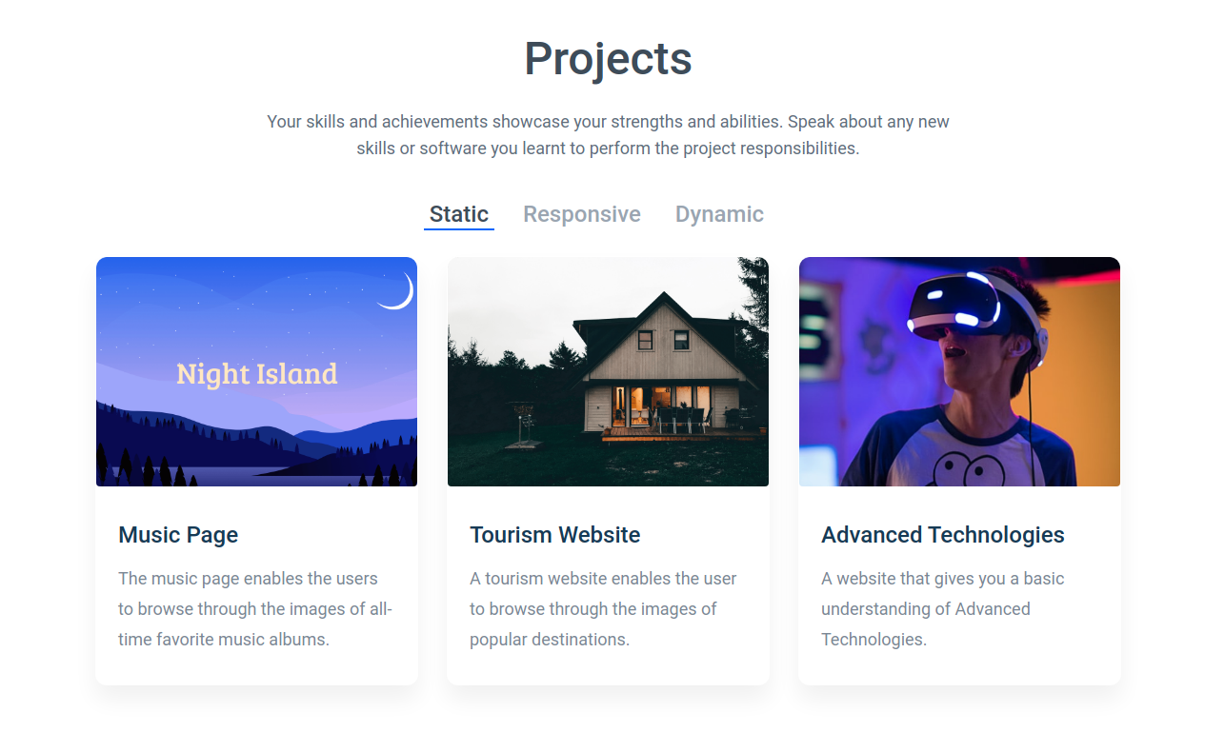

Think of all the pieces of data in the Projects Application. We have:
- The original list of projects
- The active tab item
  - The text decoration of the text - Underline
  - The color of the text
- The filtered list of projects
Let's go through each one and figure out which one is state. Ask three questions about each piece of data:
- Is it passed in from a parent via props? If so, it probably isn't state.
- Does it remain unchanged over time? If so, it probably isn't state.
- Can it be computed based on any other state or props in the component? If so, it isn't state.
Let's figure out which one is state in our application:

Data | Is State? | Reason
The original list of projects | No | It is passed as props
The active tab item | Yes | It changes over time and can't be computed  from anything
The filtered list of projects | No | It can be computed by combining the  original list of  projects with the active tab item
The text decoration of the text - Underline | No | It can be derived from the active tab item
The The color of the text | No | It can be derived from the active tab item

So finally, the state is:
- The active tab item
JSX
state = {
activeTabId: tabsList[0].tabId,
}

8. Keys
Keys help React identify which items have been changed, added, or removed.
Keys should be given to the elements inside the array to give a stable identity.
JSX
const usersList = [
{
uniqueNo: 1,
name: "Rahul",
},
{
uniqueNo: 2,
name: "Praneetha",
},
{
uniqueNo: 3,
name: "Varakumar",
},
]
const listItems = usersList.map((user) => (
<li key={user.uniqueNo}>{user.name}</li>
))

8.1 Keys in Lists
When the state of a component changes, React updates the virtual DOM tree. Once the virtual DOM has been updated, React then compares the new virtual DOM with the current virtual DOM.
Once React knows which virtual DOM objects have changed, then React updates only those objects, in the HTML DOM.
React compares the virtual DOMs if there is a change in the node, node type, or the attributes passed to the node. But there is a problematic case by only looking at the node or it's attributes. i.e. Lists.
Lists will have the same node types and attributes. Hence the list items can't be uniquely identified if they have been changed, added, or removed.
Example-1:
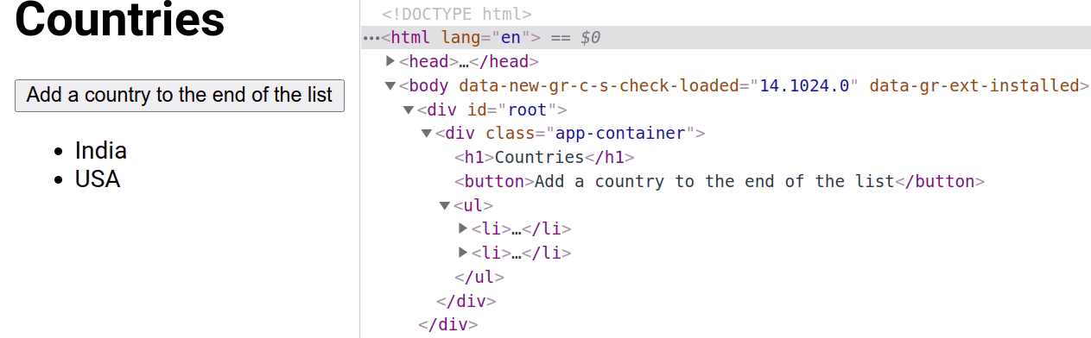
When a new list item is added to the end of the list,
- React creates a new virtual DOM with the three list items.
- React compares the first two list items in the current virtual DOM and the new virtual DOM.
- Since the two list items in both the previous and current virtual DOMs are matched, React creates only the last list item at the end in the HTML DOM.
- Example-2:
- 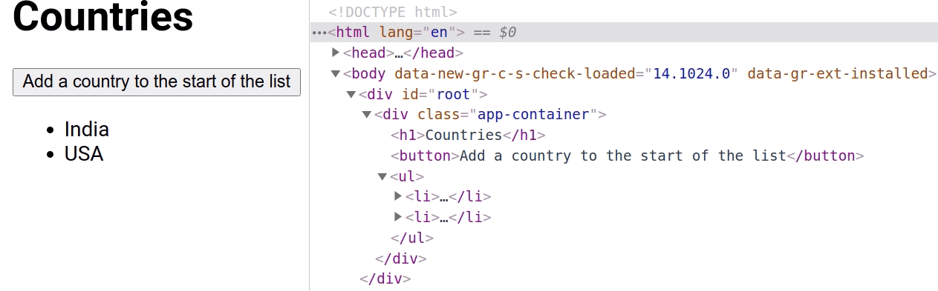
When a new list item is added to the start of the list,
- React creates a new virtual DOM with the three list items.
- React compares the first list item in the current virtual DOM and the new virtual DOM.
- Since the first list item in both the previous and current virtual DOMs is different, React treats as the whole list is changed in the current virtual DOM.
- React creates all the three list items in the HTML DOM.
So, React will recreate every element, instead of reusing the two elements that remained the same between the previous and current virtual DOMs. It leads to bad performance.
That's where keys are important. Using keys, every item in a list will have a unique identifier (ID).
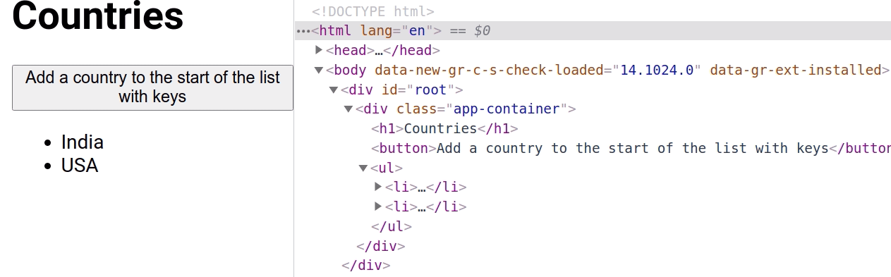
So, React can easily detect what needs to be changed or not, re-rendering only the ones with changes.

1. Third-Party Packages
A Third-Party Package is a reusable code developed to perform a specific functionality
1.1 Advantages
- Easy integration
- Saves Time
- More productivity with fewer lines of code
- Better Error Handling
- More Customisation Options ... many more.
We have used many third-party packages like React Router, React Loader, React Icons, JWT, etc.
Node Package Manager contains Third-Party Packages for React JS, Node JS, Angular JS, and many more libraries and frameworks. To know more about npm you can refer to this.
1.2 Selecting a Third-Party Package
1.2.1 Things to Consider
- Users Satisfaction
- Popularity (number of stars)
- Maintenance
- Documentation
- Number of unresolved issues
Compare the packages in the above categories and pick one for the application.
2. Third-Party Package -
react-player
NPM contains a react-player, a third-party package that provides a React component for playing a variety of URLs, including file paths, YouTube, Facebook, etc.
Installation Command:
SHELL
npm install react-player
2.1 React Player Props
We can provide different props to ReactPlayer. Below are some of the most commonly used props.
Prop | Description | Default Value
playing | Set to true or false to pause or play the media | false
controls | Set to true to display native player controls. | false
light | Set to true to show the video thumbnail, which loads  the full player on click. Pass in an image URL to override the preview image | false
width | Set the width of the player | 640px
height | Set the height of the player | 360px
className | Add the custom styles to ReactPlayer | -

Example:
File: src/App.js
JSX
import VideoPlayer from './components/VideoPlayer'
import './App.css'
const App = () => <VideoPlayer />
export default App

File: src/components/VideoPlayer/index.js
JSX
import ReactPlayer from 'react-player'
import './index.css'
const videoURL = 'https://youtu.be/YE7VzlLtp-4'
const VideoPlayer = () => (
<div className="video-container">
<h1 className="heading">Video Player</h1>
<div className="responsive-container">
<ReactPlayer url={videoURL} />
</div>
</div>
)

export default VideoPlayer

ReactPlayer Supports different types of URLs.
2.1.1 controls Prop
File: src/components/VideoPlayer/index.js
JSX
const VideoPlayer = () => (
<div className="video-container">
<h1 className="heading">Video Player</h1>
<div className="responsive-container">
<ReactPlayer url={videoURL} controls />
</div>
</div>
)
export default VideoPlayer

2.1.2 playing Prop
File: src/components/VideoPlayer/index.js
JSX
import {Component} from 'react'

import ReactPlayer from 'react-player'

import './index.css'

const videoURL = 'https://youtu.be/YE7VzlLtp-4'

class VideoPlayer extends Component {
state = {
isPlaying: false,
}

onClickPlay = () => {
this.setState(prevState => ({isPlaying: !prevState.isPlaying}))
}

render() {
const {isPlaying} = this.state
const btnText = isPlaying ? 'Pause' : 'Play'

return (
<div className="video-container">
<h1 className="heading">Video Player</h1>
<div className="responsive-container">
<ReactPlayer url={videoURL} playing={isPlaying} />
</div>
<button type="button" className="button" onClick={this.onClickPlay}>
{btnText}
</button>
</div>
)
}
}

export default VideoPlayer

Reference
To know more about react-player, you can refer to this.

1. Third-Party Package
recharts
NPM contains recharts, a third-party package to display charts in your application.
It supports different types of charts like:
- Bar Chart
- Pie Chart
- Area Chart
- Composed Chart, etc.
It supports different types of visualization methods like:
Cartesian:
- Area
- Bar
- Line, etc.
Polar:
- Pie
- Radar
- Radial Bar
- Installation Command:
npm install recharts

1.1 Advantages
- Responsive
- Built for React, from scratch
- Customizable
- 2. Bar Chart
- The BarChart Component represents the container of the Bar Chart.
- Example:
- JSX
import {
BarChart,
Bar,
XAxis,
YAxis,
Legend,
ResponsiveContainer,
} from "recharts"

const data = [
{
group_name: "Group A",
boys: 200,
girls: 400,
},
{
group_name: "Group B",
boys: 3000,
girls: 500,
},
{
group_name: "Group C",
boys: 1000,
girls: 1500,
},
{
group_name: "Group D",
boys: 700,
girls: 1200,
},
]
const App = () => {
const DataFormatter = (number) => {
if (number > 1000) {
return `${(number / 1000).toString()}k`
}
return number.toString()
}

return (
<ResponsiveContainer width="100%" height={500}>
<BarChart
data={data}
margin={{
top: 5,
}}
>
<XAxis
dataKey="group_name"
tick={{
stroke: "gray",
strokeWidth: 1,
}}
/>
<YAxis
tickFormatter={DataFormatter}
tick={{
stroke: "gray",
strokeWidth: 0,
}}
/>
<Legend
wrapperStyle={{
padding: 30,
}}
/>
<Bar dataKey="boys" name="Boys" fill="#1f77b4" barSize="20%" />
<Bar dataKey="girls" name="Girls" fill="#fd7f0e" barSize="20%" />
</BarChart>
</ResponsiveContainer>
)
}

export default App

Output:
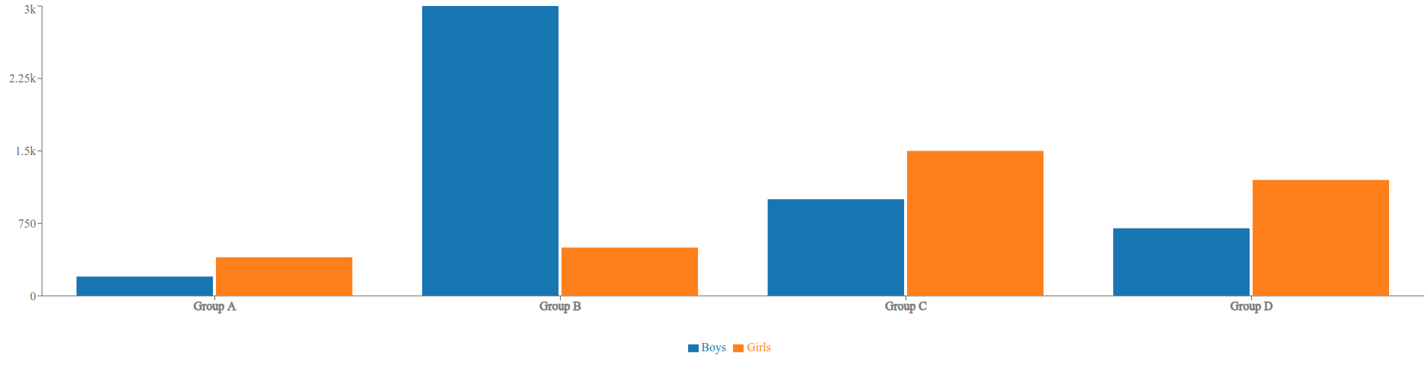
3. Components in Bar Chart
The
recharts
supports different Components for the Bar Chart. Below are some of the most commonly used Components.
3.1 ResponsiveContainer
It is a container Component to make charts adapt to the size of the parent container.
Props:
We can provide different props to the ReactJS ResponsiveContainer Component. Below are some of the most commonly used props.

Prop Default Value
width '100%' (value can be percentage string or number)
height '100%' (value can be percentage string or number)

Note
One of the props Width and height should be a percentage string in the ResponsiveContainer Component.
3.2 XAxis
The XAxis Component represents the X-Axis of a Chart.
Props:
We can provide different props to the ReactJS XAxis Component. Below are some of the most commonly used props.

Prop | Description | Default Value
dataKey | The key of the object in  data  that we want to display it's value on the axis | No default value (value can be string or number)
tick | Represents a tick | No default value. If false - No ticks will be drawn,  object - Configuration of ticks, React element –  Custom react element for drawing ticks  (value can be boolean, object or React element)
tickFormatter | The formatter function of tick | No default value (Function)
Example - tickFormatter:
If we want to show the thousands in the form of K on the tick, the formatter function would be:
JSX
const DataFormatter = (number) => {
if (number > 1000) {
return `${(number / 1000).toString()}k`
}
return number.toString()
}

3.3 YAxis
The YAxis Component represents the Y-Axis of a Chart.
The Props of the YAxis Component are similar to the XAxis Component.
3.4 Legend
The Legend Component represents the legend of a Chart.
By default, the content of the legend is generated by the name of
Line, Bar, Area, etc. If no name has been set, the prop dataKey is used to generate the content of the legend.
Props:
We can provide different props to the ReactJS Legend Component. Below are some of the most commonly used props.

Prop | Description | Default Value
iconType | The type of icon in the legend item | No default value (value can be 'line', 'plainline',  'square', 'rect', 'circle', 'cross', 'diamond','star', 'triangle', or 'wye')
layout | The layout of legend items | 'horizontal' (value can be 'horizontal' or 'vertical')
verticalAlign | The alignment of legend items in vertical direction | 'middle' (value can be 'top', 'middle', or 'bottom')
align | The alignment of legend items in horizontal direction | 'center' (value can be 'left', 'center', or 'right')
wrapperStyle | The style of the legend container | No default value (value can be React Inline styles)
3.5 Bar
The Bar Component represents a bar in the Chart.
Props:
We can provide different props to the ReactJS Bar Component. Below are some of the most commonly used props.
Prop | Description | Default Value
dataKey | The key of the object in  data  that we want to display it's value | No default value (value can be string or number)
name | The name of the bar | No default value (value can be string or number)
fill | The color to fill the rectangle in a bar | (value can be given color in hexCode or string format)
barSize | The width or height of the bar | No default value (value can be number)

Note
The value of the prop name is used in tooltip and legend to represent a bar/pie. If no value was set, the value of dataKey will be used alternatively.
4. PieChart
The PieChart Component represents the container of the Pie Chart.
Example:
JSX
import { PieChart, Pie, Legend, Cell, ResponsiveContainer } from "recharts"

const data = [
{
count: 809680,
language: "Telugu",
},
{
count: 4555697,
language: "Hindi",
},
{
count: 12345657,
language: "English",
},
]

const App = () => {
return (
<ResponsiveContainer width="100%" height={300}>
<PieChart>
<Pie
cx="70%"
cy="40%"
data={data}
startAngle={0}
endAngle={360}
innerRadius="40%"
outerRadius="70%"
dataKey="count"
>
<Cell name="Telugu" fill="#fecba6" />
<Cell name="Hindi" fill="#b3d23f" />
<Cell name="English" fill="#a44c9e" />
</Pie>
<Legend
iconType="circle"
layout="vertical"
verticalAlign="middle"
align="right"
/>
</PieChart>
</ResponsiveContainer>
)
}

export default App

Output:
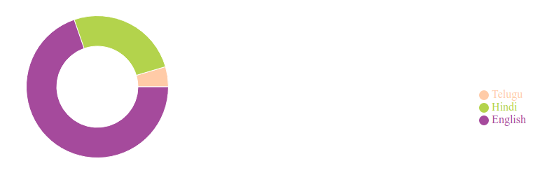
5. Components in Pie Chart
The
recharts
supports different Components for the Bar Chart. Below are some of the most commonly used Components.
5.1 Pie
The Pie Component represents a pie in the Chart.
Props:
We can provide different props to the ReactJS Pie Component. Below are some of the most commonly used props.

Prop | Description | Default Value
cx | The x-axis coordinate of a center point | '50%'. If set a percentage, the final value is obtained by multiplying the percentage of container width (value can be percentage string or number)
cy | The y-axis coordinate of a center point | '50%'. If set a percentage, the final value is obtained by multiplying the percentage of container height (value can be percentage string or number)
data | The source data in which each element is an object | No default value (value can be Array)
startAngle | The start angle of the first sector | 0 (value can be number)
endAngle | The end angle of the last sector, which should be unequal to startAngle | 360 (value can be number)
innerRadius | The inner radius of all the sectors | 0 (value can be percentage or number)
OuterRadius | The outer radius of all the sectors | 0 (value can be percentage or number)
dataKey | The key of the object in  data  that we want to display it's value on the sector | No default value

Note
If a percentage is set to the props innerRadius or outerRadius, the final value is obtained by multiplying the percentage of maxRadius which is calculated by the width, height, cx, and cy.

5.2 Cell
The Cell Component represents the cell of a Chart.
It can be wrapped by a Pie, Bar, or RadialBar Components to specify the attributes of each child.
Props:
We can provide different props to the ReactJS Cell Component. Below are some of the most commonly used props.

Prop | Description | Default Value
name | The name of the cell | No default value (can be a string. This value can be taken as the  content of the legend)
fill | The color to fill the cell | (value can be any color in hexCode or string format)

Note
The ResponsiveContainer and Legend Components in Pie Chart are similar to the Components in Bar Chart.
6. Reference
To know more about the recharts, you can refer to this.

1. Third-Party Package
react-chrono
NPM contains a react-chrono, a third-party package to display the timeline in your application.
It provides a React component
Chrono
to build a timeline that displays events chronologically.
Installation Command:
npm install react-chrono

1.1 Advantages
- Can render the timelines in three different modes (horizontal, vertical, and tree).
- Can autoplay the timeline with slideshow mode.
- Can navigate the timeline via keyboard.
- 2. Chrono Props
- We can provide different props to the ReactJS Chrono component. Below are some of the most commonly used props.
Prop | Description | Default Value
mode | Sets the mode of the component | 'HORIZONTAL' (value can be 'HORIZONTAL', 'VERTICAL' or 'VERTICAL_ALTERNATING')
items | Collection of Timeline Item Model | []
theme | Customises the colors | No default value

2.1 mode
Example:
JSX
<Chrono mode="VERTICAL" />

2.2 items
The Items prop is used to build the timeline. It is a collection of the Timeline Item Model. Timeline Item Model is an object consist of the given properties:
Name | Description | Type
title | title of the timeline item | String
cardTitle | title of the timeline card | String
cardSubtitle | text of the timeline card | String
cardDetailedText | detailed text of the timeline card | String or String[]
media | media object to set image or video | Object
Example:
CSS
.chrono-container {
width: 500px;
height: 400px;
}

import {Chrono} from 'react-chrono'

const items = [
{
title: 'May 1940',
cardTitle: 'Dunkirk',
cardSubtitle: 'Men of the British Expeditionary Force.',
cardDetailedText:
'On 10 May 1940, Hitler began his long-awaited offensive in the west by invading neutral Holland and attacking northern France.',
},
]

const App = () => (
<div className="chrono-container">
<Chrono items={items} />
</div>
)

export default App

Output:
A single timeline item is created with the values of the Timeline Item Model in the Items prop.
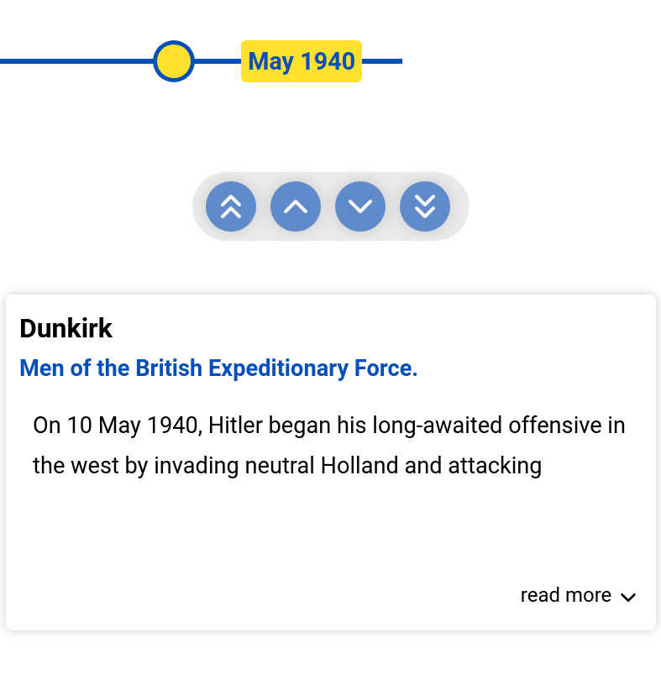

Warning
If any property misses in the Timeline Item Model, the respective value won't be displayed in the timeline item.
Note
The Chrono Component should be wrapped in a container that has a width and height.
2.3 theme
The colors can be customized with the Theme prop.
Example:
JSX
<Chrono
theme={{
primary: "red",
secondary: "blue",
cardBgColor: "yellow",
cardForeColor: "violet",
titleColor: "red",
}}
/>

3. Rendering Custom Content
The custom content can be inserted by just passing the elements between the
Chrono
tags.
Example:
The below example will create two timeline items.
CSS
.chrono-container {
width: 400px;
height: 600px;
}

.image {
width: 200px;
height: 200px;
}

import {Chrono} from 'react-chrono'

const App = () => (
<div className="chrono-container">
<Chrono mode="VERTICAL">
<div>
<img
src="https://assets.ccbp.in/frontend/react-js/csk-logo-img.png"
className="image"
alt="chennai-super-kings"
/>
</div>
<div>
<h1>Mumbai Indians</h1>
<p>IPL Team winner for the year 2019 is Mumbai Indians.</p>
</div>
</Chrono>
</div>
)

export default App

Output:
Each HTML Div element is automatically converted into a timeline item and inserted into the timeline card.

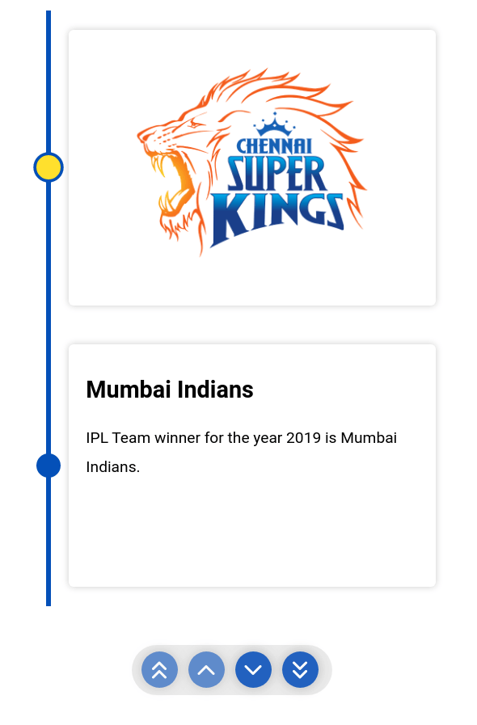

Note
The Items prop is optional and custom rendering is supported on all three modes.

Example:
The below example will set the title for the custom contents.
CSS
.chrono-container {
width: 400px;
height: 600px;
}
.image {
width: 200px;
height: 200px;
}

import {Chrono} from 'react-chrono'

const items = [{title: '2018'}, {title: '2019'}]

const App = () => (
<div className="chrono-container">
<Chrono mode="VERTICAL" items={items}>
<img
src="https://assets.ccbp.in/frontend/react-js/csk-logo-img.png"
className="image"
alt="chennai-super-kings"
/>
<div>
<h1>Mumbai Indians</h1>
<p>IPL Team winner for the year 2019 is Mumbai Indians.</p>
</div>
</Chrono>
</div>
)

export default App

Output:
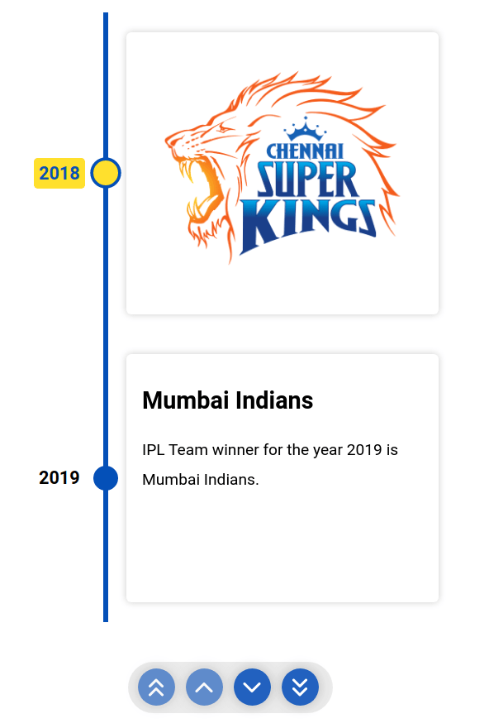
4. Reference
To know more about the react-chrono, you can refer to this.

1. Third-Party Package - react-slick
NPM contains a react-slick, a third-party package that provides a React component Slider to add a carousel to your application.
Installation Command:
npm install react-slick
Also, install slick-carousel for CSS and font
npm install slick-carousel
1.1 Advantages
- Easy to use
- Highly customizable
- More performant
- 2. Slider Props
- We can provide different props to the Slider component. Below are the most commonly used props.
Prop | Description | Default Value
slidesToShow | Specifies the number of slides to show in one frame | 1
dots | If set to false, no dots will display under the carousel | true
slidesToScroll | Specifies the number of slides to scroll at once | 1
dotsClass | CSS class for styling dots | "slick-dots"

Example:
File: src/components/ReactSlick/index.js
JSX
import Slider from 'react-slick'

import 'slick-carousel/slick/slick.css'
import 'slick-carousel/slick/slick-theme.css'

import './index.css'

const ReactSlick = () => {
const settings = {
dots: true,
slidesToShow: 1,
slidesToScroll: 1,
}
return (
<div className="slider-container">
<Slider {...settings}>
<div>
<h3>1</h3>
</div>
<div>
<h3>2</h3>
</div>
<div>
<h3>3</h3>
</div>
<div>
<h3>4</h3>
</div>
</Slider>
</div>
)
}

export default ReactSlick

File: src/components/ReactSlick/index.css
CSS
.slider-container {
background-color: #419be0;
padding: 40px;
}
File: src/App.js
JSX
import ReactSlick from './components/ReactSlick'

const App = () => {
return <ReactSlick />
}
export default App

Reference
To know more about the react-slick, you can refer to this.

1. Third-Party Package
reactjs-popup
NPM contains a reactjs-popup, a third-party package to display popup in your application.
It provides a React component that helps you create simple and complex Modals, Tooltips, and Menus for your application.
Installation Command:
npm install reactjs-popup
1.1 Advantages
- ReactJS provides Modal, Tooltip, and Menu
- Provides Support for controlled Modals & Tooltips
- 2. ReactJS Popup Props
- We can provide different props to the ReactJS Popup component. Below are some of the most commonly used props.
Prop | Description | Default Value
trigger | Represents the element to be rendered  in-place where the Popup is defined | JSX element
modal | When set to true, Popup content will be displayed as  a modal on the trigger of Popup. If not tooltip will be displayed | false
position | Defines the position of the tooltip. It can be  one of 'top left', 'top right', 'bottom right', 'bottom left' | bottom center
open | Defines the state of Popup. Whether it is opened or not | false
overlayStyle | Custom overlay style | object

2.1 trigger Prop
File: src/components/ReactPopup/index.js
JSX
import Popup from 'reactjs-popup'

import 'reactjs-popup/dist/index.css'

import './index.css'

const ReactPopUp = () => (
<div className="popup-container">
<Popup
trigger={
<button className="trigger-button" type="button">
Trigger
</button>
}
>
<div>
<p>React is a popular and widely used programming language</p>
</div>
</Popup>
</div>
)
export default ReactPopUp

File: src/components/ReactPopup/index.css
CSS
.trigger-button {
font-size: 16px;
font-weight: 400;
font-family: 'Roboto';
color: white;
padding: 8px 15px 8px 15px;
margin: 8px;
background-color: #7c69e9;
border: none;
border-radius: 4px;
outline: none;
}
.popup-container {
display: flex;
align-items: center;
justify-content: center;
height: 100vh;
}

File: src/App.js
JSX
import ReactPopup from './components/ReactPopup'

const App = () => {
return <ReactPopup />
}
export default App

Note
The value of the trigger prop should be a JSX element.

2.2 modal Prop
File: src/components/ReactPopup/index.js
JSX
const ReactPopUp = () => (
<div className="popup-container">
<Popup
modal
trigger={
<button type="button" className="trigger-button">
Trigger
</button>
}
>
<p>React is a popular and widely used programming language</p>
</Popup>
</div>
)
export default ReactPopUp

2.3 modal Prop with close button
File: src/components/ReactPopup/index.js
JSX
const ReactPopUp = () => (
<div className="popup-container">
<Popup
modal
trigger={
<button type="button" className="trigger-button">
Trigger
</button>
}
>
{close => (
<>
<div>
<p>React is a popular and widely used programming language</p>
</div>
<button
type="button"
className="trigger-button"
onClick={() => close()}
>
Close
</button>
</>
)}
</Popup>
</div>
)export default ReactPopUp
2.4 position Prop
File: src/components/ReactPopup/index.js
JSX
const ReactPopUp = () => (
<div className="popup-container">
<Popup
trigger={
<button type="button" className="trigger-button">
Trigger
</button>
}
position="bottom left"
>
<p>React is a popular and widely used programming language</p>
</Popup>
</div>
)
export default ReactPopUp

2.5 overlayStyle Prop
File: src/components/ReactPopup/index.js
JSX
const overlayStyles = {
backgroundColor: '#ffff',
}
const ReactPopUp = () => (
<div className="popup-container">
<Popup
modal
trigger={
<button type="button" className="trigger-button">
Trigger
</button>
}
overlayStyle={overlayStyles}
>
<p>React is a popular and widely used programming language</p>
</Popup>
</div>
)
export default ReactPopUp

Reference
To know more about the reactjs-popup, you can refer to this.

1. Prop Drilling
Props are passed from one Component to another Component that does not need the data but only helps in passing it through the tree is called Prop Drilling.
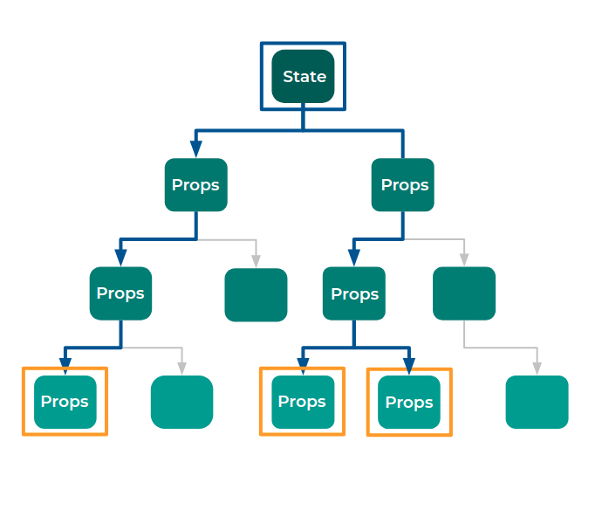
2. React Context
Context is a mechanism that provides different Components and allows us to pass data without doing prop drilling.
2.1 Creating Context
Syntax:
JSX
React.createContext(INITIAL_VALUE)
It returns an object with different properties to update and access values from the context.
2.2 Context Properties
The Context object provides two properties.
- Consumer
- Provider
2.3 How to Access the Value?
We can access the value in the Context using Consumer Component provided by the Context Object.
3. Consumer Component
Syntax:
JSX
<ContextObject.Consumer>
{/*callback function*/}
</ContextObject.Consumer>

- We access the Consumer component using dot notation from the context object.
- We will give a callback function as children for Consumer Component.
- 3.1 Understanding Syntax
- The callback function receives the current context value as an argument and returns a component or a JSX element.
- 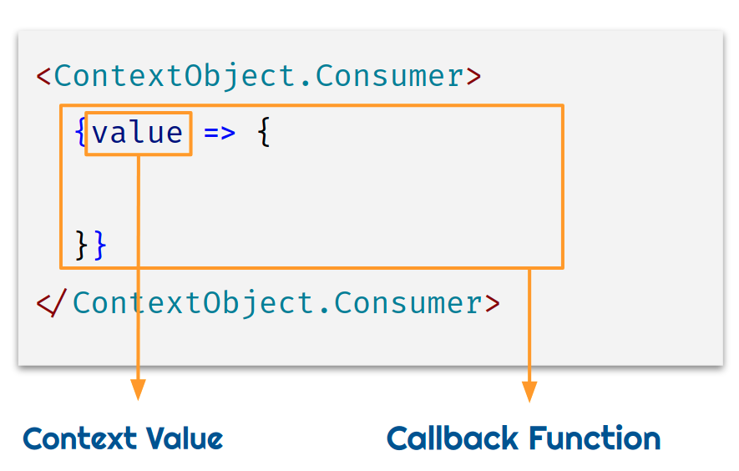
5. Google Translator
- In the Windows App example, we are using three different languages to display the text.
- You can translate one language to another language using google translator.
- Check google translator website here .

1. Provider
- Provider Component updates the value of Context.
- When the provider updates context, all the nested consumers of that provider will be re-rendered.
- Updated context value can only be accessed by the consumers nested within the provider.
JSX
<ContextObject.Provider value={/* some value */}>
...
<ContextObject.Provider/>

To update context value, we have to pass it as a prop to the Provider component.

2. Context Flow For Windows App
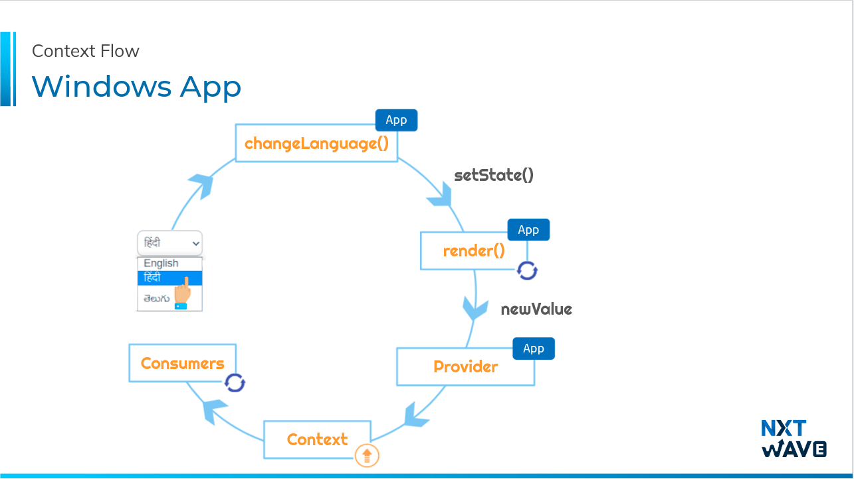
3. Best Practice
- The context value should have the data which the consumers need.
- It should also contain the required methods to update that data.
- 4.Final Code
- File: src/App.js
- JSX
import {Component} from 'react'

import Header from './components/Header'
import LandingSection from './components/LandingSection'
import FeaturesSection from './components/FeaturesSection'

import LanguageContext from './context/LanguageContext'

import './App.css'

class App extends Component {
state = {activeLanguage: 'EN'}

changeLanguage = activeLanguage => {
this.setState({activeLanguage})
}

render() {
const {activeLanguage} = this.state
return (
<LanguageContext.Provider
value={{activeLanguage, changeLanguage: this.changeLanguage}}
>
<Header />
<LandingSection />
<FeaturesSection />
</LanguageContext.Provider>
)
}
}

export default App

File: src/context/LanguageContext.jsx
JSX
import React from 'react'

const LanguageContext = React.createContext({
activeLanguage: 'EN',
changeLanguage: () => {},
})

export default LanguageContext

File: src/components/FeaturesSection/index.js
JSX
import Playtime from '../Playtime'
import NewWaysToConnect from '../NewWaysToConnect'

import './index.css'

const FeaturesSection = () => (
<div className="features-section-container">
<Playtime />
<NewWaysToConnect />
</div>
)

export default FeaturesSection

File: src/components/Header/index.js
JSX
import LanguageContext from '../../context/LanguageContext'

import './index.css'

const langOptions = [
{id: 1, value: 'EN', language: 'English'},
{id: 2, value: 'HI', language: 'हिंदी'},
{id: 3, value: 'TE', language: 'తెలుగు'},
]

const Header = () => (
<LanguageContext.Consumer>
{value => {
const {activeLanguage, changeLanguage} = value
const onChangeLanguage = event => {
changeLanguage(event.target.value)
}

return (
<nav className="nav-header">
<img
className="website-logo"
src="https://assets.ccbp.in/frontend/react-js/windows-logo-img.png"
alt="website logo"
/>
<select
className="language-dropdown"
value={activeLanguage}
onChange={onChangeLanguage}
>
{langOptions.map(eachOption => (
<option key={eachOption.id} value={eachOption.value}>
{eachOption.language}
</option>
))}
</select>
</nav>
)
}}
</LanguageContext.Consumer>
)

export default Header

File: src/components/LandingSection/index.js
JSX
import LanguageContext from '../../context/LanguageContext'

import './index.css'

const landingSectionContent = {
EN: {
heading: 'Windows 11',
description:
'Windows 11 provides a calm and creative space where you can pursue your passions through a fresh experience. From a rejuvenated Start menu to new ways to connect to your favorite people, news, games, and content. Windows is the place to think, express, and create in a natural way.',
},
HI: {
heading: 'विंडोज 11',
description:
'विंडोज 11 एक शांत और रचनात्मक स्थान प्रदान करता है जहां आप एक नए अनुभव के माध्यम से अपने जुनून को आगे बढ़ा सकते हैं। अपने पसंदीदा लोगों, समाचारों, गेमों और सामग्री से जुड़ने के नए तरीकों से एक नए सिरे से शुरू किए गए स्टार्ट मेनू से विंडोज एक प्राकृतिक तरीके से सोचने, व्यक्त करने और बनाने का स्थान है।',
},
TE: {
heading: 'విండోస్ 11',
description:
'విండోస్ 11 ప్రశాంతమైన మరియు సృజనాత్మక స్థలాన్ని అందిస్తుంది, ఇక్కడ మీరు మీ అభిరుచులను తాజా అనుభవం ద్వారా కొనసాగించవచ్చు. పునరుజ్జీవింపబడిన ప్రారంభ మెను నుండి మీకు ఇష్టమైన వ్యక్తులు, వార్తలు, ఆటలు మరియు కంటెంట్‌తో కనెక్ట్ అవ్వడానికి కొత్త మార్గాల వరకు విండోస్ అనేది సహజంగా ఆలోచించే, వ్యక్తీకరించే మరియు సృష్టించే ప్రదేశం.',
},
}

const LandingSection = () => {
const getLandingSectionData = activeLanguage => {
switch (activeLanguage) {
case 'EN':
return landingSectionContent.EN
case 'HI':
return landingSectionContent.HI
case 'TE':
return landingSectionContent.TE
default:
return null
}
}
return (
<LanguageContext.Consumer>
{value => {
const {activeLanguage} = value
const {heading, description} = getLandingSectionData(activeLanguage)
return (
<div className="bg-container">
<div className="responsive-container">
<div className="description-container">
<h1 className="heading">{heading}</h1>
<p className="description">{description}</p>
</div>
<img
className="logo-white"
src="https://assets.ccbp.in/frontend/react-js/windows-logo-white-img.png"
alt="windows logo"
/>
</div>
</div>
)
}}
</LanguageContext.Consumer>
)
}

export default LandingSection

File: src/components/NewWaysToConnect/index.js
JSX
import LanguageContext from '../../context/LanguageContext'

import './index.css'

const newWaysToConnectContent = {
EN: {
heading: 'New ways to connect',
description:
'Connect instantly to the people you care about right from your desktop with Microsoft Teams. Call or chat for free, no matter what device they’re on.',
},
HI: {
heading: 'कनेक्ट करने के नए तरीके',
description:
'माइक्रोसॉफ्ट टीमों के साथ सीधे अपने डेस्कटॉप से ​​उन लोगों से तुरंत कनेक्ट हों जिनकी आप परवाह करते हैं। कॉल करें या निःशुल्क चैट करें—चाहे वे किसी भी डिवाइस पर हों।',
},
TE: {
heading: 'కనెక్ట్ చేయడానికి కొత్త మార్గాలు',
description:
'మైక్రోసాఫ్ట్ బృందాలతో మీ డెస్క్‌టాప్ నుండి మీరు శ్రద్ధ వహించే వ్యక్తులతో తక్షణమే కనెక్ట్ అవ్వండి. అవి ఏ పరికరంలో ఉన్నా సరే ఉచితంగా కాల్ చేయండి లేదా చాట్ చేయండి',
},
}

const NewWaysToConnect = () => {
const getNewWaysToConnectData = activeLanguage => {
switch (activeLanguage) {
case 'EN':
return newWaysToConnectContent.EN
case 'HI':
return newWaysToConnectContent.HI
case 'TE':
return newWaysToConnectContent.TE
default:
return null
}
}
return (
<LanguageContext.Consumer>
{value => {
const {activeLanguage} = value
const {heading, description} = getNewWaysToConnectData(activeLanguage)
return (
<div className="new-ways-to-connect-container">
<h1 className="new-ways-to-content-heading">{heading}</h1>
<p className="new-ways-to-content-description">{description}</p>
</div>
)
}}
</LanguageContext.Consumer>
)
}

export default NewWaysToConnect

File: src/components/Playtime/index.js
JSX
import LanguageContext from '../../context/LanguageContext'

import './index.css'

const playtimeContent = {
EN: {
heading: 'Playtime. Anytime',
description:
'Windows takes gaming to a whole new level with graphic capabilities that rival reality. Discover your next favorite game with Xbox GamePass, giving you access to over 100 high-quality games.',
},
HI: {
heading: 'विश्राम का समय। किसी भी समय',
description:
'विंडोज़ गेमिंग को ग्राफ़िक क्षमताओं के साथ एक नए स्तर पर ले जाता है जो वास्तविकता को टक्कर देता है। एक्सबॉक्स गेम पास के साथ अपना अगला पसंदीदा गेम खोजें, जिससे आपको 100 से अधिक उच्च-गुणवत्ता वाले गेम तक पहुंच मिलती है।',
},
TE: {
heading: 'ఆడూకునే సమయం. ఎప్పుడైనా',
description:
'రియాలిటీకి ప్రత్యర్థిగా ఉండే గ్రాఫిక్ సామర్థ్యాలతో విండోస్ గేమింగ్‌ను సరికొత్త స్థాయికి తీసుకువెళుతుంది . మీ తదుపరి ఇష్టమైన ఆటను ఎక్స్‌బాక్స్ గేమ్‌పాస్‌తో కనుగొనండి, మీకు 100 కి పైగా అధిక-నాణ్యత ఆటలకు ప్రాప్యతను ఇస్తుంది.',
},
}

const Playtime = () => {
const getPlaytimeData = activeLanguage => {
switch (activeLanguage) {
case 'EN':
return playtimeContent.EN
case 'HI':
return playtimeContent.HI
case 'TE':
return playtimeContent.TE
default:
return null
}
}
return (
<LanguageContext.Consumer>
{value => {
const {activeLanguage} = value
const {heading, description} = getPlaytimeData(activeLanguage)
return (
<div className="playtime-container">
<h1 className="playtime-heading">{heading}</h1>
<div className="playtime-description-container">
<p className="playtime-description">{description}</p>
<img
className="playtime-games-image"
src="https://assets.ccbp.in/frontend/react-js/gaming-pad-img.png"
alt="gaming pad"
/>
</div>
</div>
)
}}
</LanguageContext.Consumer>
)
}

export default Playtime

1. Context
Context can also be used:
- When data has to be available between different Routes.
- When data has to be available for more number of Components
2. Using Context in methods
- We can add consumer or provider in the class method when it returns JSX.
- In the below code snippet, we have used Consumer Component in renderProductDetailsView because this method is returning JSX.
Example:
File: src/components/ProductItemDetails
JSX
import { Component } from "react";
import Cookies from "js-cookie";
import Loader from "react-loader-spinner";
import { BsPlusSquare, BsDashSquare } from "react-icons/bs";

import CartContext from "../../context/CartContext";

import Header from "../Header";
import SimilarProductItem from "../SimilarProductItem";

import "./index.css";

const apiStatusConstants = {
initial: "INITIAL",
success: "SUCCESS",
failure: "FAILURE",
inProgress: "IN_PROGRESS",
};

class ProductItemDetails extends Component {
state = {
productData: {},
similarProductsData: [],
apiStatus: apiStatusConstants.initial,
quantity: 1,
};

componentDidMount() {
this.getProductData();
}
getFormattedData = (data) => ({
availability: data.availability,
brand: data.brand,
description: data.description,
id: data.id,
imageUrl: data.image_url,
price: data.price,
rating: data.rating,
title: data.title,
totalReviews: data.total_reviews,
});

getProductData = async () => {
const { match } = this.props;
const { params } = match;
const { id } = params;

this.setState({
apiStatus: apiStatusConstants.inProgress,
});
const jwtToken = Cookies.get("jwt_token");
const apiUrl = `https://apis.ccbp.in/products/${id}`;
const options = {
headers: {
Authorization: `Bearer ${jwtToken}`,
},
method: "GET",
};
const response = await fetch(apiUrl, options);
if (response.ok) {
const fetchedData = await response.json();
const updatedData = this.getFormattedData(fetchedData);
const updatedSimilarProductsData = fetchedData.similar_products.map(
(eachSimilarProduct) => this.getFormattedData(eachSimilarProduct)
);
this.setState({
productData: updatedData,
similarProductsData: updatedSimilarProductsData,
apiStatus: apiStatusConstants.success,
});
}
if (response.status === 404) {
this.setState({
apiStatus: apiStatusConstants.failure,
});
}
};

renderLoadingView = () => (
<div className="products-details-loader-container">
<Loader type="ThreeDots" color="#0b69ff" height="50" width="50" />
</div>
);
renderFailureView = () => (
<div className="product-details-error-view-container">
<img
alt="error view"
src="https://assets.ccbp.in/frontend/react-js/nxt-trendz-error-view-img.png"
className="error-view-image"
/>
<h1 className="product-not-found-heading">Product Not Found</h1>
<button type="button" className="button">
Continue Shopping
</button>
</div>
);

onDecrementQuantity = () => {
const { quantity } = this.state;
if (quantity > 1) {
this.setState((prevState) => ({ quantity: prevState.quantity - 1 }));
}
};

onIncrementQuantity = () => {
this.setState((prevState) => ({ quantity: prevState.quantity + 1 }));
};
renderProductDetailsView = () => (
<CartContext.Consumer>
{(value) => {
const { productData, quantity, similarProductsData } = this.state;
const {
availability,
brand,
description,
imageUrl,
price,
rating,
title,
totalReviews,
} = productData;
const { addCartItem } = value;
const onClickAddToCart = () => {
addCartItem({ ...productData, quantity });
};
return (
<div className="product-details-success-view">
<div className="product-details-container">
<img src={imageUrl} alt="product" className="product-image" />
<div className="product">
<h1 className="product-name">{title}</h1>
<p className="price-details">Rs {price}/-</p>
<div className="rating-and-reviews-count">
<div className="rating-container">
<p className="rating">{rating}</p>
<img
src="https://assets.ccbp.in/frontend/react-js/star-img.png"
alt="star"
className="star"
/>
</div>
<p className="reviews-count">{totalReviews} Reviews</p>
</div>
<p className="product-description">{description}</p>
<div className="label-value-container">
<p className="label">Available:</p>
<p className="value">{availability}</p>
</div>
<div className="label-value-container">
<p className="label">Brand:</p>
<p className="value">{brand}</p>
</div>
<hr className="horizontal-line" />
<div className="quantity-container">
<button
type="button"
className="quantity-controller-button"
onClick={this.onDecrementQuantity}
>
<BsDashSquare className="quantity-controller-icon" />
</button>
<p className="quantity">{quantity}</p>
<button
type="button"
className="quantity-controller-button"
onClick={this.onIncrementQuantity}
>
<BsPlusSquare className="quantity-controller-icon" />
</button>
</div>
<button
type="button"
className="button add-to-cart-btn"
onClick={onClickAddToCart}
>
ADD TO CART
</button>
</div>
</div>
<h1 className="similar-products-heading">Similar Products</h1>
<ul className="similar-products-list">
{similarProductsData.map((eachSimilarProduct) => (
<SimilarProductItem
productDetails={eachSimilarProduct}
key={eachSimilarProduct.id}
/>
))}
</ul>
</div>
);
}}
</CartContext.Consumer>
);

renderProductDetails = () => {
const { apiStatus } = this.state;

switch (apiStatus) {
case apiStatusConstants.success:
return this.renderProductDetailsView();
case apiStatusConstants.failure:
return this.renderFailureView();
case apiStatusConstants.inProgress:
return this.renderLoadingView();
default:
return null;
}
};
render() {
return (
<>
<Header />
<div className="product-item-details-container">
{this.renderProductDetails()}
</div>
</>
);
}
}

export default ProductItemDetails;

3. Final code
Run the below command in your IDE to download the final code.
ccbp start RJSIVIJ1YR
1. Deploying the Ecommerce Application Code
Run the below command in your IDE to publish the Ecommerce Application Code.
ccbp publish RJSIV4YSTX domain.ccbp.tech
Here the domain is the domain name to be published.
Quick Tip
To look good in your resume, use your name and nxttrendz as the domain name in the domain URL. For example,
rahulnxttrendz.ccbp.tech
.
Warning
An error will be thrown if you are trying to publish with the already existing URL.
Note
A maximum of only 15 characters is allowed in the domain name.
2. Ecommerce Application - Final Code
Run the below command in your IDE to download the final code of an Ecommerce Application.
ccbp start RJSIVPP7N7

1. Styling React Components
React Components can be styled in different ways:
- Using CSS
- CSS-in-JS
- SASS & SCSS
  - many more...
1.1 Using CSS
Writing CSS in external CSS files for each component and passing class name as a value to the className attribute.
File: src/App.js
JSX
import "./App.css";
const App = () => <h1 className="heading">Hello World</h1>;
export default App;

File: src/App.css
JSX
.heading {
color: #0070c1;
font-family: 'Roboto';
}

1.2 CSS-in-JS
CSS-in-JS is a styling technique where JavaScript is used to style React Components. It can be implemented using the below third party packages.
- Styled Components
- Emotion
- Radium many more...
- 2. Styled Components
- Styled Components are one of the new ways to use CSS in modern JavaScript. Components are used to reuse code, similarly Styled Components are used to reuse styles.
- 2.1 Installation
npm install styled-components

2.2 Syntax
JSX
const StyledComponentName = styled.tagName`
property1: value1;
property2: value2;
...
`;

Within the template literals (), we define the styles.
Note
StyledComponentName should always start with a Capital letter.
2.3 Importing styled
In general, styled components are placed inside the styledComponents.js file.
File: src/styledComponents.js
JSX
import styled from "styled-components";
styled is an internal utility method that transforms the styling from JavaScript into actual CSS.
2.4 Creating and Exporting Styled Component
File: src/styledComponents.js
JSX
import styled from "styled-components";

export const Heading = styled.h1`
color: #0070c1;
font-family: "Roboto";
`;

2.5 Importing and Rendering Styled Component
File: src/App.js
JSX
import "./App.css";
import { Heading } from "./styledComponents";
const App = () => <Heading>Hello World</Heading>;
export default App;

2.6 Adapting based on props
- With styled components we can re-use the styles created.
JSX
<StyledComponent propName="propValue">...</StyledComponent>

Syntax:
JSX
const StyledComponentName = styled.tagName`
property1 : value1;
property2: ${props => /* access prop value */ };
...
`

Example:
File: src/App.js
JSX
import "./App.css";
import { CustomButton } from "./styledComponents";

const App = () => (
<>
<CustomButton type="button" color="#ffffff" bgColor="#0070c1">Click</CustomButton>
<CustomButton type="button" color="#0070c1" bgColor="#ffffff">Click</CustomButton>
</>
);
export default App;

File: src/styledComponents.js
JSX
import styled from "styled-components";

export const CustomButton = styled.button`
padding: 10px;
margin-right: 20px;
font-size: 15px;
color: ${(props) => props.color};
border-radius: 4px;
border: 2px solid #0070c1;
background-color: ${(props) => props.bgColor};
`;

- Value passed as prop can be accessed as props.propName.
2.7 Modularity of Code
Example:
File: src/App.js
JSX
<CustomButton type="button" outline={false}>Click</CustomButton>

The color and bgColor are the part of styling, instead of passing them as props, we can passthe type of button to handle styles in styled components.
2.8 Conditional Styling using Props
JSX
Condition ? Expression If True : Expression If False;
const StyledComponentName = styled.tagName`
property1 : value1;
property2: ${(props) => (props.name === someValue ? value2 : value3)};
...
`;

Example:
File: src/App.js
JSX
import "./App.css";
import { CustomButton } from "./styledComponents";

const App = () => (
<>
<CustomButton type="button" outline={false}>Click</CustomButton>
<CustomButton type="button" outline={true}>Click</CustomButton>
</>
);

export default App;

File: src/styledComponents.js
JSX
import styled from "styled-components";

export const CustomButton = styled.button`
padding: 10px;
margin-right: 20px;
font-size: 15px;
color: ${(props) => (props.outline ? "#0070c1" : "#ffffff")};
border-radius: 4px;
border: 2px solid #0070c1;
background-color: ${(props) => (props.outline ? "#ffffff" : "#0070c1")};
`;

3.Advantages of Styled Components
3.1 Unique Class Names
Styled Components generate a unique class name(s) for your styles.
Example:
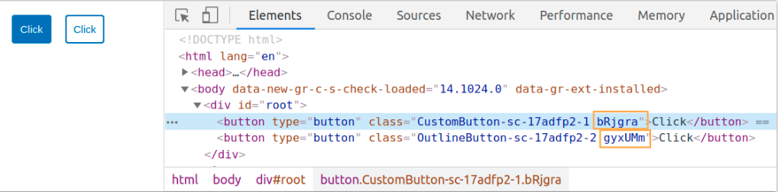
3.2 Elimination of dead styles
Styled components remove unused styles, even if they’re declared in your code.
3.3 Dynamic Styling
- Let’s assume we have two types of buttons on our page, one with a white background, and the other navy blue.
- We do not have to create two styled-components for them. We can adapt their styling based on their props.
File:src/styledComponents.js
JSX
import styled from "styled-components";

export const CustomButton = styled.button`
padding: 10px;
margin-right: 20px;
font-size: 15px;
color: ${(props) => (props.outline ? "#0070c1" : "#ffffff")};
border-radius: 4px;
border: 2px solid #0070c1;
background-color: ${(props) => (props.outline ? "#ffffff" : "#0070c1")};
`;

File:src/App.js
JSX
import "./App.css";
import { CustomButton } from "./styledComponents";

const App = () => (
<>
<CustomButton type="button" outline={false}>Click</CustomButton>
<CustomButton type="button" outline={true}>Click</CustomButton>
</>
);

export default App;

3.4 Can differentiate between the types of props they receive
File:src/App.js
JSX
import "./App.css";
import { CustomButton } from "./styledComponents";

const App = () => (
<>
<CustomButton outline={false}>Click</CustomButton>
<CustomButton outline={true}>Click</CustomButton>
</>
);

export default App;

You’ll notice, though, that we haven’t given our button a type in the above code snippet. Let’s do that:
File:src/App.js
JSX
import "./App.css";
import { CustomButton } from "./styledComponents";

const App = () => (
<>
<CustomButton type="button" outline={false}>Click</CustomButton>
<CustomButton type="submit" onClick={() => alert("clicked")} outline={true} >Click</CustomButton>
</>;
);

export default App;

Styled components can differentiate between the types of props they receive. They know that type is an HTML attribute, so they render
<button type="button">Click</button>
, while using the outline prop in their own processing. Notice how we attached an event handler, too?
3.5 Easier Debugging
- babel-plugin-styled-components plugin adds support for a nicer debugging experience.
- This option enhances the attached CSS class name on each component with richer output to help identify your components in the DOM without React DevTools. In your page source you'll see:
<button type="button" class="CustomButton-asdfxxx asdfxx" />
instead of just
<button type="button" class="asdfxxx" />
.

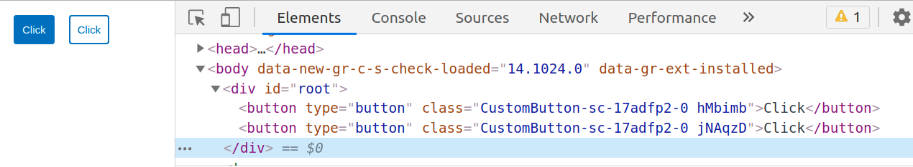
- It also allows you to see the component's displayName in React DevTools. For example, consider writing a styled component that renders a button element, called CustomButton. It will normally show up in DevTools as styled.button, but with the displayName option enabled, it has the name you gave it CustomButton.
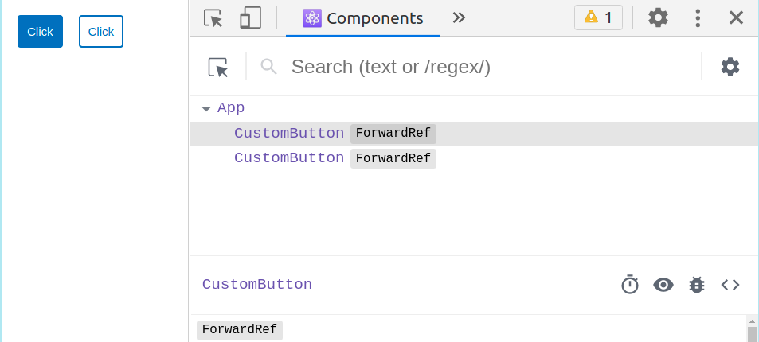
- This makes it easier to find your components and to figure out where they live in your app.
- For more info, you can go through this link here.
Note
- In order to configure create-react-app with the babel-plugin-styled-components, we have to use craco - Create React App Configuration Override is an easy and comprehensible configuration layer for create-react-app.
- We’ll need to install craco with npm, and then create a craco.config.js at the root of our application, with the content:
JSX
module.exports = {
babel: {
plugins: [
[
"babel-plugin-styled-components",
{
fileName: false,
},
],
],
},
};
It is already configured.

3.6 Global Styling
- We will write global styles in the
styledComponents.js
file. Inside the
GlobalStyle
variable is where we define all global styles.
- We will import
GlobalStyle
component and place it at the top of React tree. In many react applications, that’s typically the
App.js
file.
- createGlobalStyle
is a helper function to generate a special StyledComponent that handles global styles.
- Normally, styled-components are automatically scoped to a local CSS class and therefore isolated from other components. In the case of createGlobalStyle, this limitation is removed.
Example:
File: src/styledComponents.js
JSX
import { createGlobalStyle } from "styled-components";

export const GlobalStyle = createGlobalStyle`
body {
margin: 0;
font-family: -apple-system, BlinkMacSystemFont, "Segoe UI", "Roboto", "Oxygen",
"Ubuntu", "Cantarell", "Fira Sans", "Droid Sans", "Helvetica Neue",
sans-serif;
-webkit-font-smoothing: antialiased;
-moz-osx-font-smoothing: grayscale;
}
`;

File: src/App.js
JSX
import { CustomButton } from "./styledComponents";
import { GlobalStyle } from "./styledComponents";

const App = () => (
<>
<GlobalStyle />
<CustomButton type="button">Click</CustomButton>
<CustomButton type="button" outline>Click</CustomButton>
</>
);

export default App;
- To know more, you can go through this link.
4. Extending Styles
- Frequently you might want to use a component, but change it slightly for a single case. Now, you could pass in a function and change them based on some props, but that's quite a lot of effort for overriding the styles once.
- To easily make a new component that inherits the styling of another, just wrap it in the styled(). Here we use the CustomButton and create a special one, extending it with some color-related styling.
JSX
import styled from "styled-components";

export const CustomButton = styled.button`
padding: 10px;
margin-right: 20px;
font-size: 15px;
color: #ffffff;
border-radius: 4px;
border: 2px solid #0070c1;
background-color: #0070c1;
`;

- Now we need to create another StyledComponent with similar properties of CustomButton except color and border-color property.
JSX
import styled from "styled-components";

export const OutlineButton = styled(CustomButton)`
color: #0070c1;
background-color: #ffffff;
font-family: "Open sans";
`;
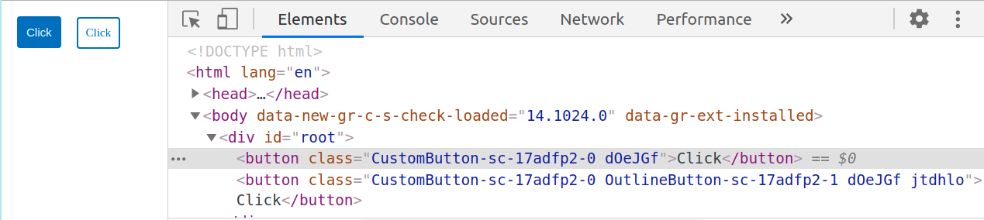

- It’s more or less like how the spread operator works.
- To know more, you can go through this link.
Note
You will get a HTML button element rendered for OutlineButton.

5. The "as" prop
- You can pass the as prop to your styled component with the value of your preferred element.
- If you want to keep all the styling you've applied to a component but just switch out what's being ultimately rendered (be it a different HTML tag or a different custom component), you can use the "as" prop to do this at runtime.
Example:
File:src/App.js
JSX
import "./App.css";
import { CustomButton } from "./styledComponents";

const App = () => (
<>
<CustomButton outline={false}>Click</CustomButton>
<CustomButton as="a" href="#" outline={true}>Click</CustomButton>
</>
);

export default App;

File:src/styledComponents.js
JSX
import styled from "styled-components";

export const CustomButton = styled.button`
padding: 10px;
margin-right: 20px;
font-size: 15px;
color: ${(props) => (props.outline ? "#0070c1" : "#ffffff")};
border-radius: 4px;
border: 2px solid #0070c1;
background-color: ${(props) => (props.outline ? "#ffffff" : "#0070c1")};
`;

- Consider the above code snippet, here the OutlineButton styled component is rendered as a button element, but you would prefer an anchor to a button for OutlineButton, you can pass the
as
a prop to your styled component with the value of your preferred element.
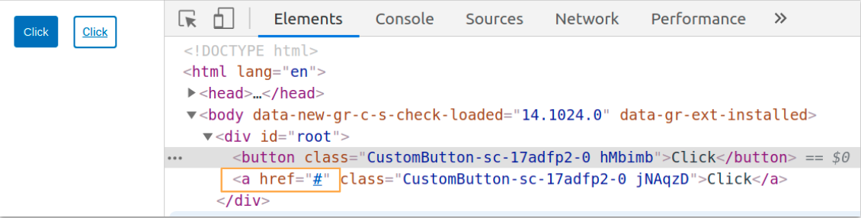
- This sort of thing is very useful in use cases like a navigation bar where some of the items should be links and some just buttons, but all be styled the same way.
6. Boolean Attribute
- The Presence of boolean attribute is taken as true no need to specify the value again.
- The absence of boolean attribute is taken as false.
JSX
import "./App.css";
import { CustomButton } from "./styledComponents";

const App = () => (
<>
<CustomButton type="button">Click</CustomButton>
<CustomButton type="button" outline>Click</CustomButton>
</>
);

export default App;

